Unequal Impact of Lethal Heatwaves in India for Males
and Females: Insights from Climate Projection Data

Aanchala Bhongade*
* Visiting Researcher, Cambridge Collective Intelligence & Design Group, (Undergrad at VJTI, Mumbai)
Under the supervision of Dr. Ramit Debnath, University of Cambridge, UK

Keywords
Heatwaves, Cooling Energy Demand, Heat Index, Climate Projections, Gender-Based Vulnerabilities, Cooling Degree Days, India, SSPs (Shared Socioeconomic Pathways)

Abstract
As climate change accelerates, extreme heatwaves pose increasing risks in India, with differential impacts across gender and age groups. Using data from the World Bank Climate Knowledge Portal and CMIP6 models, we obtained time-series data for relative humidity and mean surface air temperature (1990–2100) across SSPs (1-1.9 to 5-8.5) and calculated the heat index using a standardized formula, incorporating uncertainty bounds from median, 10th, and 90th percentiles [1]. Heat index maps were generated to visualize these variations across SSPs. To estimate total cooling energy demand, we analyzed population projections (2020–2100) for males and females in conjunction with historical sales data of ceiling fans and air conditioners, incorporating energy consumption factors [2]. Contour plots illustrated the relationship between heat index, energy consumption, and age-wise gender differences, showing that cooling energy demand increases with age and higher heat index values. Scatter plots further revealed how heat index fluctuations shape energy demand. Additionally, a correlation plot examines the link between Cooling Degree Days (CDD) and gender-based variations, emphasizing how rising temperatures influence cooling needs. The findings underscore why heatwaves will have an unequal impact on men and women in India and why this is troubling for future pathways. Clarifying these differences is important to foster nuanced climate adaptation strategies that acknowledge the increasing energy needs and concerning vulnerabilities associated with extreme heat.

Introduction
Climate change has significantly intensified heat stress in India, driven by rising temperatures and humidity levels, which are effectively captured by the heat index (HI) [1]. The heat index, a combined measure of temperature and relative humidity, provides a critical indicator of perceived heat stress and its impact on human health and energy systems. As temperatures continue to rise, the frequency and intensity of heatwaves are projected to increase in India, particularly under high-emission scenarios such as the Shared Socioeconomic Pathways (SSPs). The SSPs are a set of scenarios developed to explore how global society, demographics, and economics might evolve over the 21st century, influencing greenhouse gas emissions and climate change outcomes. These pathways describe five distinct futures—SSP1 (Sustainability), SSP2 (Middle of the Road), SSP3 (Regional Rivalry), SSP4 (Inequality), and SSP5 (Fossil-fueled Development)—each representing different socioeconomic trajectories and their implications for climate mitigation and adaptation challenges [3]. For instance, SSP1-1.9 envisions a sustainable world with low emissions, while SSP5-8.5 projects a fossil-fuel-intensive future with high emissions.
The escalating heat stress has profound implications for energy demand in India, particularly for cooling, as populations seek to mitigate heat-related risks. Cooling energy demand, primarily driven by the use of air conditioners (ACs) and fans, is expected to surge in the coming decades, placing significant pressure on energy infrastructure. This study estimates cooling energy consumption using sales data for ACs and fans, weighted by population distributions across different age groups and genders. We hypothesize that cooling energy demand in India may vary significantly with age and heat index, potentially influenced by demographic factors such as population aging.
Age plays a crucial role in determining heat vulnerability and energy use patterns in India. Older populations are generally more susceptible to heat stress due to physiological limitations, which may lead to higher cooling energy demand to maintain thermal comfort. However, the extent to which age and gender influence cooling demand under varying heat stress conditions remains underexplored in the Indian context. These demographic dynamics are further complicated by population aging projected under different SSPs, which influences both the size and structure of India’s future population [4]. Despite these insights, few studies have integrated age- and gender-disaggregated population data with heat index and cooling energy demand projections across SSPs in India, leaving a critical gap in understanding the interplay between climate, energy, and demographics.
This study aims to address this gap by investigating the relationship between heat index and cooling energy demand in India, weighted by age and gender distributions, across SSP1-1.9, SSP1-2.6, SSP2-4.5, SSP3-7.0, and SSP5-8.5 from 2020 to 2099. Using climate projection data from the World Bank Climate Projection portal, which provides time-series datasets for average mean surface air temperature, relative humidity, and population under various SSPs, we quantify how heat stress drives cooling energy consumption and how this varies across different age groups and genders under future socioeconomic scenarios [5]. By employing contour plots and a scatter plot analysis that compares heat index and cooling energy consumption across different SSPs, we provide a comprehensive assessment of the combined effects of heat index, population dynamics, and energy demand, offering insights for climate adaptation and energy planning in India.

Literature Review
The increasing frequency and intensity of heatwaves in India, driven by climate change, have heightened the focus on heat stress and its implications for energy demand and sustainable development. Heat stress, often measured through the heat index (HI), which integrates temperature and relative humidity, serves as a vital indicator of human health risks and energy requirements. In India, heatwaves have become more frequent and severe, particularly in urban centers, posing significant challenges to public health, labor productivity, and energy infrastructure [1]. Studies highlight that heat stress increases mortality risks, diminishes economic productivity, and drives up cooling energy demand, emphasizing the need for integrated strategies to address these issues amid rapid urbanization and socioeconomic disparities [1].
Cooling energy demand in India has witnessed a sharp rise in recent years, propelled by the widespread adoption of air conditioners (ACs) and fans as primary measures to mitigate heat stress. According to the India Energy Scenario: For the year 2023-24 | 2nd Edition, there has been a notable increase in AC sales between 2021-22 and 2023-24, with a growing proportion of energy-efficient star-rated ACs, reflecting both heightened cooling needs and a shift toward energy efficiency [6]. The same report indicates that cooling appliances, such as ACs and fans, constitute a significant share of household electricity consumption, particularly in urban areas where heat stress is more acute, though data gaps in rural and informal sectors may lead to underestimations of total demand [6]. These findings align with global trends, where cooling energy demand in tropical regions like India is projected to rise sharply due to increasing temperatures [7]. Projections suggest that global residential cooling demand could triple by 2050 under high-emission scenarios, a trend that is particularly relevant for India given its climate and socioeconomic conditions [7]. However, India’s energy infrastructure faces challenges in meeting this demand, with frequent power outages and a heavy reliance on fossil fuels exacerbating greenhouse gas emissions [1].
The role of demographic factors, such as age and gender, in shaping cooling energy demand has received limited attention in the Indian context, despite their potential to influence energy consumption patterns. Older populations are more susceptible to heat stress due to physiological constraints, which may lead to greater cooling needs to ensure thermal comfort [8]. Research indicates that age-related vulnerabilities increase heat-related health risks, potentially translating into higher energy use for cooling among aging populations [8]. Gender differences in heat perception and adaptive behavior may also impact energy consumption, though India-specific evidence on this topic remains limited [1]. Studies acknowledge that demographic variations, including age and gender, contribute to heat vulnerability, but they often do not directly explore how these factors influence cooling energy demand [1]. Population aging, projected under different Shared Socioeconomic Pathways (SSPs), further complicates these dynamics by altering India’s demographic structure over time [4]. The SSPs, which outline a spectrum of socioeconomic futures from sustainability (SSP1) to fossil-fueled development (SSP5), provide a framework for modeling the combined impacts of climate and demographic changes on energy demand [3]. For example, SSP5-8.5, a high-emission scenario, projects severe heat stress by the end of the century, while SSP1-1.9 envisions a more sustainable future with reduced climate impacts [3].
Climate projection data have been widely used to study heat stress and its socioeconomic implications under SSPs, offering time-series projections for temperature, humidity, and population [3]. However, few studies have leveraged such data to examine cooling energy demand in India with a focus on age- and gender-disaggregated populations. While global studies have modeled cooling demand under SSPs, they often fail to account for India-specific demographic dynamics and the unique challenges of its energy sector, such as limited rural electrification and reliance on fossil fuels [7]. In India, research on cooling energy demand has primarily focused on aggregate trends, such as AC penetration rates and total energy consumption, without considering how age and gender distributions influence demand [6]. Additionally, the application of SSPs to India-specific contexts remains underexplored, with most studies focusing on broader regional or global scales [3].
The integration of heat index, cooling energy demand, and demographic factors in the Indian context remains a critical research gap. Energy consumption studies in India, such as those presented in the India Energy Scenario: For the year 2023-24 | 2nd Edition, provide valuable insights into cooling trends but lack a detailed examination of demographic influences [6]. Furthermore, the use of SSPs to model India-specific demographic and energy dynamics under varying heat stress scenarios has been underexplored, despite the availability of robust climate projection data [3]. This study addresses these gaps by investigating the relationship between heat index and cooling energy demand in India, weighted by age and gender distributions, across SSP1-1.9, SSP1-2.6, SSP2-4.5, SSP3-7.0, and SSP5-8.5 from 2020 to 2099. By combining climate projection data with energy consumption estimates, this research provides a nuanced understanding of how heat stress, population dynamics, and energy demand interact in the Indian context.

Methodology
Data Sources
This study relied on comprehensive time-series datasets from the World Bank Climate Change Knowledge Portal to obtain climate and demographic data for India under various Shared Socioeconomic Pathways (SSPs), specifically SSP1-1.9, SSP1-2.6, SSP2-4.5, SSP3-7.0, and SSP5-8.5, covering the period from 2020 to 2099 [5]. The climate data included monthly average mean surface temperature and relative humidity, along with their associated uncertainties, which were critical for calculating the heat index. These datasets were selected because they provide high-resolution projections under multiple SSPs, enabling a detailed assessment of future heat stress in India. The uncertainties in the temperature and humidity data were provided as standard deviations, which were later used to compute the 10th and 90th percentiles of the heat index, ensuring a robust analysis of heat stress variability [9]. Population data, disaggregated by age (in 5-year intervals: 0–4, 5–9, ..., 95+) and gender (male and female), were sourced from the "Heat Risks" section of the same database. These demographic datasets provided population projections for each SSP over the same time period, allowing for an analysis of how heat stress impacts vary across different age groups and genders under future socioeconomic scenarios.
To estimate cooling energy demand, sales data for air conditioners (ACs) and fans were obtained from the Bureau of Energy Efficiency (BEE) Final Report [2]. This dataset included annual sales figures for ACs and fans in India, which were used as a proxy for cooling device adoption and usage. The use of sales data to estimate cooling energy consumption is a well-established method in energy demand studies, as it reflects the penetration of cooling technologies in response to rising temperatures [10].
Heat Index Calculation
The heat index (HI) was calculated to quantify perceived heat stress, using the formula proposed by Rothfusz (1990), which integrates temperature and relative humidity to provide a measure of how hot it feels to the human body [11]:
HI=−42.379+2.04901523T+10.14333127RH−0.22475541TRH−6.83783×10⁻³×T²−5.481717×10⁻²RH²+1.22874×10⁻³T²RH+8.5282×10⁻⁴TRH²−1.99×10⁻⁶T²RH²
where T is the temperature in degrees Fahrenheit (°F) and RH is the relative humidity in percentage (%). The temperature and humidity data from the World Bank Climate Projection site were initially provided in degrees Celsius and percentage, respectively. To apply the formula, temperature values were converted from Celsius to Fahrenheit using the standard conversion formula:
T(°F)=T(°C)×9/5+32T(°F)=T(°C)×9/5+32
Monthly temperature and humidity data were averaged to obtain annual values for each year from 2020 to 2099, ensuring consistency with the temporal resolution of the population data.
To account for uncertainties in the climate projections, the 10th and 90th percentiles of the heat index were computed for each SSP. This was done by applying the heat index formula to the lower and upper bounds of the temperature and humidity data, derived from their reported uncertainties (standard deviations). For each year, the mean heat index was calculated using the mean temperature and humidity, while the 10th and 90th percentiles were computed using the mean minus/plus one standard deviation for both variables, a method commonly used in climate impact studies to capture the range of potential heat stress levels [9]. This approach provided a comprehensive view of heat stress variability under each SSP, which was later visualized to assess trends over time, as described in the next subsection.
Heat Index Visualization
The heat index data, along with its 10th and 90th percentile ranges, were visualized to assess trends over time for each SSP. The visualization process involved calculating anomalies and normalized values relative to a historic reference period (1991–2014). First, a historic reference moving average was computed by taking the 5-year rolling mean of the heat index data from 1991 to 2014 and calculating the median across all years in this period. Anomalies were then calculated for the post-2015 data by subtracting the historic moving average from the heat index values for each SSP. Additionally, the heat index data were normalized by dividing the anomalies by the historic moving average, providing a relative measure of heat stress change over time.
The heat index, its anomalies, and normalized values were plotted using Python’s matplotlib library. For each SSP (SSP1-1.9, SSP1-2.6, SSP2-4.5, SSP3-7.0, SSP5-8.5), the heat index was plotted against the years (1991–2099), with shaded areas representing the 10th and 90th percentile ranges to indicate uncertainty. The historic mean (1950–2014) was also plotted as a reference line, with its own uncertainty bounds (10th and 90th percentiles) shaded in gray. Three types of plots were generated: (1) a heat index anomaly plot, showing the deviation from the historic mean; (2) a normalized heat index plot, showing the relative change; and (3) an original heat index plot with uncertainty bounds, including the historic data. These visualizations were saved for presentation in the Results section.
Cooling Energy Demand Estimation
Cooling energy demand was estimated using sales data for air conditioners (ACs) and ceiling fans, following a multi-step process to convert sales figures into energy consumption and project future demand. The process began with the extraction and preparation of historical sales data for ACs and fans from 2020 to 2039, sourced from [2]. When real sales values were missing, approximations were made based on trends in the available data, a common practice in energy demand studies when dealing with incomplete datasets [10].
Energy Consumption Calculation
To estimate the energy consumption associated with cooling devices, certain assumptions were made about the energy usage of each appliance:
- Ceiling Fans: Estimated to consume 0.05 TWh per million units sold annually, based on an average power rating of 50 W and typical usage patterns (e.g., 8 hours per day during the cooling season).
- Air Conditioners (ACs): Estimated to consume 1.5 TWh per million units sold annually, based on an average power rating of 1.5 kW and similar usage assumptions.
The energy consumption for each year was calculated using the following formulas:
- Fan Energy Consumption:
Fan Energy Consumption (TWh)=(Fan Sales/10⁶)×0.05
- AC Energy Consumption:
AC Energy Consumption (TWh)=(AC Sales/10⁶)×1.5
- Total Estimated Cooling Consumption:
Total Estimated Cooling Consumption (TWh)=Fan Energy Consumption+AC Energy Consumption
This calculation provided the historical dataset of total cooling energy consumption (in TWh) for each year from 2020 to 2039, reflecting the combined energy usage of ACs and fans based on their sales.
Linear Regression for Forecasting
To project cooling energy consumption from 2040 to 2099, a linear regression model was applied to the historical data (2020–2039). The independent variable (X) was the year, representing the timeline, and the dependent variable (y) was the total estimated cooling consumption (in TWh). Linear regression was chosen because it effectively captures linear trends in energy demand, a method widely used in energy demand forecasting studies [12]. The regression model was trained to fit a straight line to the historical data, expressed as:
Total Estimated Cooling Consumption= β0 + β1 × Year + ϵ
where β0​ is the intercept, β1​ is the slope coefficient, and ϵ is the error term.
The model was implemented using Python’s scikit-learn library, with the following steps:
- The years (2020–2039) and corresponding total cooling energy consumption values were extracted as the input (X) and output (y) variables, respectively.
- A linear regression model was trained using the LinearRegression class from scikit-learn, fitting the model to the historical data.
- The trained model was then used to predict cooling energy consumption for the years 2040 to 2099 by inputting future years as the independent variable.
- The predicted values were combined with the historical data to create a complete dataset of cooling energy consumption from 2020 to 2099, which was saved for further analysis.

Weighting by Population
The total cooling energy consumption was then weighted by the population distributions across different age groups and genders for each SSP. For each year and SSP, the cooling energy consumption was multiplied by the population of each age group (0–4, 5–9, ..., 95+) and gender (male and female), as follows:
Weighted Cooling Energy (Age Group, Gender)=Total Cooling Energy×Population (Age Group, Gender)
This direct multiplication approach ensured that the cooling demand reflected the population size of each age group and gender, without normalizing by the total population, aligning with the method used to generate the contour plots. Missing values in the cooling energy data, population data, or heat index data were handled by replacing NaNs with the mean value of the respective dataset (e.g., using np.nan_to_num with the mean), ensuring a complete dataset for analysis. Weighting energy demand by population demographics is a common method in energy studies to capture the influence of population dynamics on consumption patterns [7]. The weighted cooling energy consumption was then used as the primary variable for visualization and analysis.

Data Visualization and Analysis
To analyze the relationship between heat index, cooling energy demand, and population dynamics, a multi-faceted visualization approach was employed. Contour plots were generated to depict the variation of weighted cooling energy demand with heat index, age, and gender across four time periods: 2020–2039, 2040–2059, 2060–2079, and 2080–2099 for each SSP (SSP1-1.9, SSP1-2.6, SSP2-4.5, SSP3-7.0, and SSP5-8.5). Separate contour plots were created for males and females, resulting in 40 plots (5 SSPs × 4 time periods × 2 genders). The plots were generated using Python’s matplotlib and scipy libraries, with the following steps:
- The heat index, population, and cooling energy data were loaded for each SSP, time period, and gender.
- Missing values were handled by replacing NaNs with the mean value of the respective dataset.
- The weighted cooling energy consumption was calculated by multiplying the cooling energy by the population of each age group.
- A meshgrid was created with the heat index (sorted in ascending order) on the x-axis and age groups on the y-axis.
- The weighted cooling energy values were interpolated over the meshgrid using scipy.interpolate.griddata with the linear method, creating a smooth surface for contour plotting.
- The contour plot was generated using matplotlib.pyplot.contourf, with the heat index on the x-axis, age groups on the y-axis, and weighted cooling energy consumption as the color gradient (in TWh), with a colorbar indicating the energy scale.
These plots provide a detailed view of how cooling energy demand changes with age and heat index, weighted by the population of each age group, under different SSP scenarios. Contour plots are a common tool in climate and energy studies for visualizing multi-dimensional relationships [13].
A scatter plot was created to compare cooling energy consumption with heat index across all SSPs, with each SSP represented by a different color. The scatter plot was generated using Python’s matplotlib library, with the following steps:
- The heat index and cooling energy consumption data were loaded for the years 1991 to 2099.
- Heat index values were extracted for each SSP (SSP1-1.9, SSP1-2.6, SSP2-4.5, SSP3-7.0, SSP5-8.5), and cooling energy consumption was extracted for the same years.
- Scatter points were plotted for each SSP, with heat index on the x-axis and cooling energy consumption on the y-axis, using different colors for each SSP (e.g., blue for SSP1-1.9, green for SSP1-2.6, etc.).
- Axis limits were set to clip outliers (x-axis: 77–89°C, y-axis: 4–15 TWh), and custom ticks were applied for readability, with the x-axis ticks ranging from 77 to 90°C (in increments of 0.8) and y-axis ticks from 4 to 16 TWh (in increments of 1).
The scatter plot highlights the overall relationship between heat stress and cooling demand over the years, illustrating how different socioeconomic pathways affect energy consumption trends. Scatter plots are frequently used in climate-driven energy demand studies to assess the direct relationship between climate variables and energy use [14].
Additionally, correlation plots were generated to examine the relationship between cooling degree days (CDD) and population (male and female, age-wise) for each SSP. CDD was calculated as the annual sum of the differences between the daily mean temperature and a base temperature (18°C), a standard metric for assessing cooling needs [12]. The correlation plots were created using Python’s matplotlib and seaborn libraries, with the following steps:
- Load the datasets for Cooling Degree Days (CDD), population data (male and female).
- Combine CDD values with the male and female population data to create a dataframe suitable for correlation analysis.
- Calculate the correlation between CDD and male/female populations using .corr() function in pandas. This will give us a correlation matrix.
- Use seaborn or matplotlib to plot the correlation matrix as a heatmap.
- The correlation plots were generated for each SSP, showing the strength of the relationship between CDD and population across age groups and genders.
Correlation analysis is a widely applied technique in energy studies to explore the influence of demographic factors on consumption patterns [4]. These plots provide insight into the demographic drivers of cooling energy demand under different SSP scenarios.
The overall analytical flow began with the acquisition and processing of climate and demographic data, followed by the calculation of the heat index and its uncertainty ranges. Cooling energy demand was then estimated using sales data, linear regression, and population weighting. Finally, the relationships between heat index, cooling energy demand, and population were visualized through contour, and scatter plots. This comprehensive approach allowed for a detailed assessment of how heat index varies with increased cooling energy consumption, influenced by age and gender, under different SSP scenarios in India.

Results
The heat index exhibited a consistent increase across all Shared Socioeconomic Pathways (SSPs), with SSP5-8.5 showing the most significant rise by 2099 due to elevated temperature and humidity projections. Figure 1 illustrates the heat index trends with 10th and 90th percentile ranges for SSP1-1.9, SSP1-2.6, SSP2-4.5, SSP3-7.0, and SSP5-8.5 from 1991 to 2099. Under SSP1-1.9, the heat index remains relatively stable, increasing from approximately 78°F in 1991 to 80°F by 2099, reflecting the low-emission scenario’s mitigation efforts. In contrast, SSP5-8.5 shows a steep rise, reaching up to 89°F by 2099, with the 90th percentile exceeding 90°F, indicating severe heat stress in this high-emission scenario. The uncertainty bounds (10th to 90th percentiles) widen over time, particularly for SSP5-8.5, highlighting the increasing variability in heat stress projections as emissions rise.
The scatter plot (Figure 2) compares cooling energy consumption with heat index across all SSPs from 1991 to 2099, with each SSP represented by a different color. The plot reveals a positive relationship between heat index and cooling energy consumption, with energy demand increasing as heat index rises. For SSP1-1.9 (blue), cooling energy consumption remains relatively low, ranging from 4 TWh to 6 TWh, corresponding to a heat index of 77–80°F. In contrast, SSP5-8.5 (purple) shows a significant increase, with cooling energy consumption reaching up to 14 TWh by 2099 at a heat index of 89°F, reflecting the higher heat stress and corresponding energy demand in this scenario. The scatter plot also indicates that the rate of increase in cooling energy consumption accelerates as the heat index exceeds 85°F, particularly for SSP3-7.0 and SSP5-8.5, suggesting a threshold effect where cooling demand surges under extreme heat conditions.
Contour plots reveal distinct patterns in weighted cooling energy demand across age groups, genders, and SSPs over the four time periods (2020–2039, 2040–2059, 2060–2079, 2080–2099). Figures 3–10 present a subset of contour plots for SSP1-1.9 and SSP5-8.5 for 2020–2039 and 2080–2099, with the full set available in Supplementary Figures S1–S32. For SSP1-1.9 in 2020–2039, males aged 50–54 exhibit the highest weighted cooling energy consumption, peaking at 5 TWh at a heat index of approximately 78°F (Figure 3), while females in the same age group show a slightly lower peak of 4.5 TWh (Figure 4). By 2080–2099, SSP1-1.9 showed a modest increase in heat index to 79.5°F, with males aged 50–64 reaching 3.5 TWh and females at 3.2 TWh (Figures 5–6). In contrast, SSP5-8.5 in 2080–2099 shows a significant escalation, with the heat index reaching 89°F. Males aged 50–64 in this scenario peak at 4 TWh, and females reach 4.4 TWh (Figures 7–8), reflecting the intensified heat stress and higher cooling demand in this high-emission scenario. Across all SSPs and time periods, older age groups (50–64) consistently show higher cooling energy demand compared to younger groups (e.g., 20–24, which peak at around 2 TWh), highlighting the age-related vulnerability to heat stress. Gender differences in cooling energy demand are minimal, with females occasionally showing slightly higher demand (e.g., SSP5-8.5, 2080–2099), but the variation is not significant.
Correlation plots between cooling degree days (CDD) and population (male and female) across age groups reveal the demographic drivers of cooling energy demand. Figures 11–14 present a subset of correlation plots for SSP1-1.9 and SSP5-8.5 for 2020–2039 and 2080–2099, with the full set available in Supplementary Figures S33–S48. For SSP1-1.9 in 2020–2039, the correlation between CDD and male population is strongly negative (–0.82), and similarly negative for females (–0.82) (Figure 11), indicating that as CDD increases, the population size decreases, likely due to demographic shifts such as aging or migration. By 2080–2099, the correlation weakens slightly to –0.65 for males and –0.73 for females (Figure 12), reflecting changes in population dynamics over time. For SSP5-8.5 in 2020–2039, the correlation is also strongly negative (–0.86 for both males and females) (Figure 13), but by 2080–2099, it shifts to a weak positive correlation (0.19 for males, 0.03 for females) (Figure 14), suggesting that under high-emission scenarios, population growth in certain age groups may align more closely with increasing CDD. Across all SSPs, the correlation between CDD and itself is 1.0, as expected, and the correlation between male and female populations remains strongly positive (0.97–1.0), indicating similar demographic trends for both genders.

Discussion
The results highlight the escalating heat stress in India under different SSPs, with SSP5-8.5 projecting the most severe conditions by 2099, as shown in Figure 1. This aligns with previous studies that predict a significant increase in heat stress in tropical regions under high-emission scenarios [15]. The steep rise in heat index under SSP5-8.5, reaching 89°F with a 90th percentile exceeding 90°F, underscores the urgent need for robust climate mitigation strategies to prevent extreme heatwaves, which pose significant risks to public health and energy systems [1]. The scatter plot (Figure 2) further confirms the strong positive relationship between heat index and cooling energy consumption, with a notable threshold effect above 85°F, where energy demand surges. This threshold effect is consistent with findings that cooling demand increases exponentially with temperature in tropical climates [16], placing additional pressure on India’s energy infrastructure, which already faces challenges with frequent power outages and reliance on fossil fuels [6].
The contour plots (Figures 3–42) reveal that older age groups (50–64) consistently exhibit higher cooling energy demand across all SSPs and time periods, supporting the hypothesis that age-related vulnerabilities drive increased cooling needs [8]. For instance, in SSP1-1.9 (2020–2039), males aged 50–54 peak at 5 TWh, while in SSP5-8.5 (2080–2099), the demand for the same age group reaches 4 TWh for males and 4.4 TWh for females, reflecting the combined impact of higher heat index and population aging. This trend is particularly concerning given India’s projected demographic shift toward an older population under SSPs [4], which will likely exacerbate cooling energy demand in the future. The minimal gender differences in cooling energy demand suggest that while physiological and behavioral differences between males and females may exist [17], they do not significantly influence cooling needs in this context, possibly due to similar exposure to heat stress and access to cooling technologies.
The correlation plots (Figures 43–62) provide insight into the demographic drivers of cooling energy demand. The strong negative correlation between CDD and population in earlier periods (e.g., –0.86 for SSP5-8.5 in 2020–2039) indicates that as heat stress (measured by CDD) increases, population sizes in certain age groups decrease, likely due to aging or migration patterns [18]. However, the shift to a weak positive correlation in SSP5-8.5 by 2080–2099 (0.19 for males, 0.03 for females) suggests that under high-emission scenarios, population growth in heat-stressed regions may eventually align with increasing CDD, potentially driven by urban migration or population growth in younger age groups [19]. This shift has significant implications for energy planning, as it indicates a growing population exposed to higher cooling needs in the future.
The findings underscore the unequal impact of heatwaves on different demographic groups in India, particularly older populations, who face higher heat vulnerability and cooling energy needs. This aligns with global studies showing that aging populations are more susceptible to heat stress, requiring targeted adaptation measures [20]. The minimal gender differences in cooling demand contrast with some studies that suggest females may be more vulnerable to heat stress due to physiological factors [21], indicating that socioeconomic factors, such as access to cooling technologies, may play a larger role in India. The increasing cooling energy demand under high-emission scenarios like SSP5-8.5 poses a challenge for India’s energy sector, which must balance rising demand with sustainability goals [6]. Strategies such as promoting energy-efficient cooling technologies, improving rural electrification, and implementing heat action plans tailored to vulnerable groups (e.g., the elderly) are critical for mitigating these impacts [22].

Conclusion
This study demonstrates that heat index-driven cooling energy demand in India varies significantly with age and gender across SSP1-1.9, SSP1-2.6, SSP2-4.5, SSP3-7.0, and SSP5-8.5 from 2020 to 2099, with profound implications for energy planning and climate adaptation. The heat index projections (Figure 1) reveal a stark contrast between low-emission (SSP1-1.9) and high-emission (SSP5-8.5) scenarios, with SSP5-8.5 projecting a heat index of 89°F by 2099, exacerbating heat stress and cooling needs [15]. The scatter plot (Figure 2) confirms a strong positive relationship between heat index and cooling energy consumption, with demand surging above a heat index of 85°F, particularly in high-emission scenarios, highlighting the urgent need for sustainable energy solutions to meet this rising demand [16].
The contour plots (Figures 3–10) show that older age groups (50–64) consistently exhibit higher cooling energy demand across all SSPs, driven by their increased vulnerability to heat stress [8]. This trend, coupled with India’s projected population aging under SSPs [4], suggests that future cooling energy demand will be heavily influenced by demographic shifts, necessitating targeted interventions for the elderly. The minimal gender differences in cooling demand indicate that while physiological variations between males and females exist [17], socioeconomic factors such as access to cooling technologies may play a more significant role in India [1]. The correlation plots (Figures 11–14) further reveal that cooling degree days (CDD) and population dynamics are closely linked, with a shift from negative to positive correlations in high-emission scenarios like SSP5-8.5 by 2080–2099, reflecting potential population growth in heat-stressed regions [18].
These findings underscore the need for nuanced climate adaptation strategies in India that address the unequal impacts of heatwaves on different demographic groups. Promoting energy-efficient cooling technologies, as suggested by prior studies [22], and improving rural electrification can help mitigate the rising energy burden while reducing greenhouse gas emissions [6]. Additionally, heat action plans tailored to vulnerable populations, particularly the elderly, are essential to reduce heat-related health risks [20]. Future research should explore localized heat stress impacts, incorporate socioeconomic factors such as income and urban-rural disparities, and assess the effectiveness of adaptation measures in reducing cooling energy demand [23]. Integrating renewable energy sources into India’s cooling infrastructure could further support sustainable development goals, ensuring resilience against the escalating impacts of climate change [24].

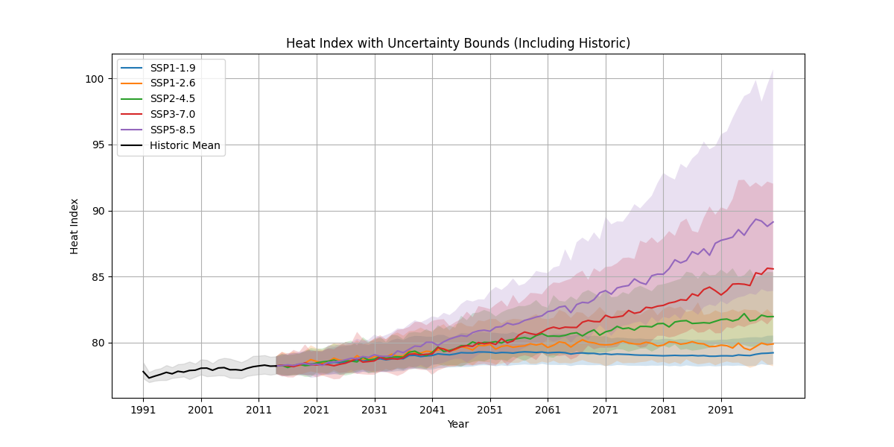
Plots

Figure 1: Heat Index with Uncertainty Bounds (Including Historic) for SSP1-1.9, SSP1-2.6, SSP2-4.5, SSP3-7.0, and SSP5-8.5 (1991–2099)
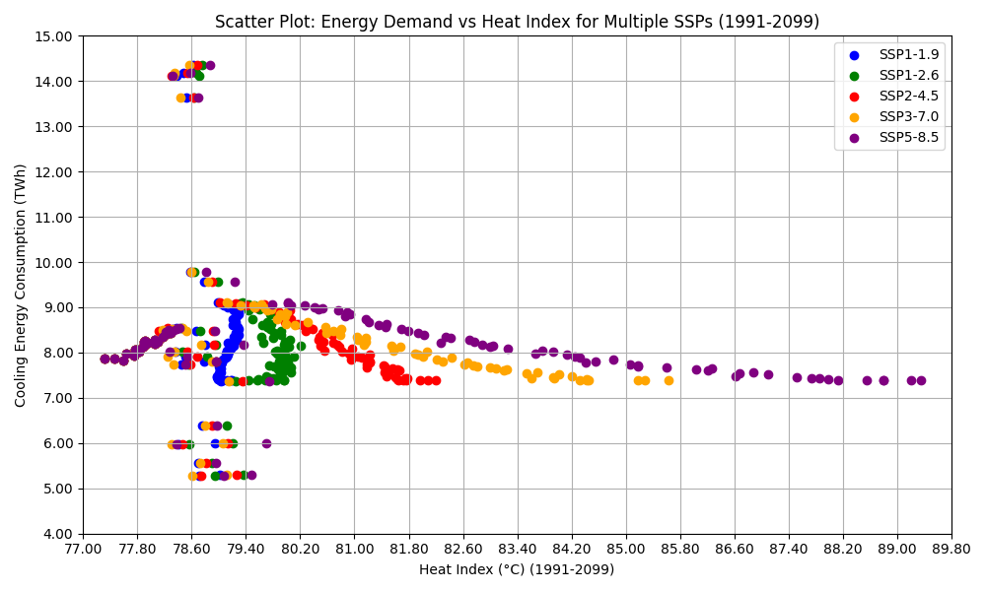

Figure 2: Scatter Plot of Energy Demand vs. Heat Index for Multiple SSPs (1991–2099)
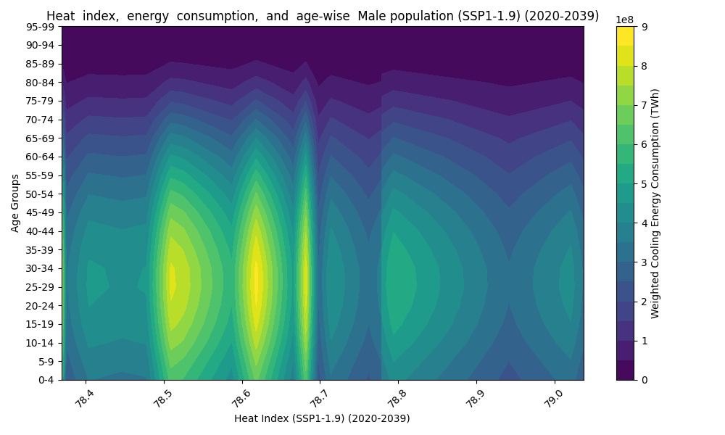
Figure 3: Males, SSP1-1.9 (2020–2039)
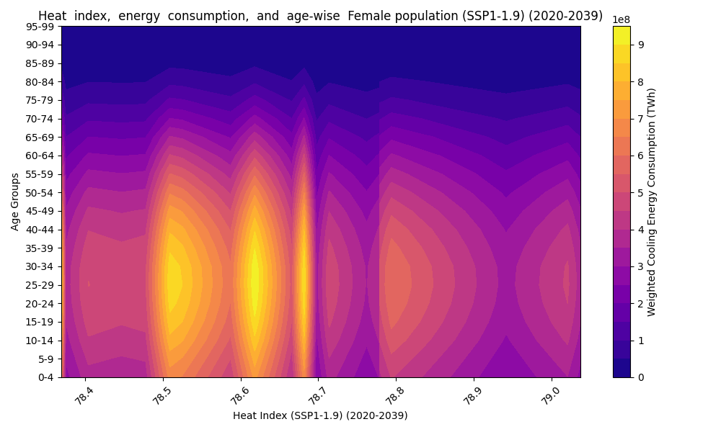
Figure 4: Females, SSP1-1.9 (2020–2039)
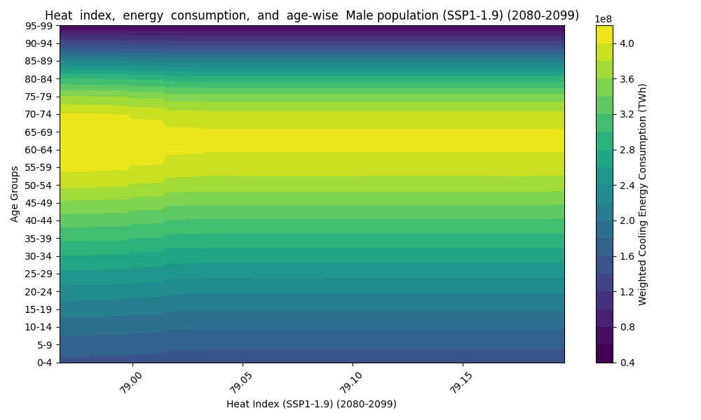
Figure 5: Males, SSP1-1.9 (2080–2099)
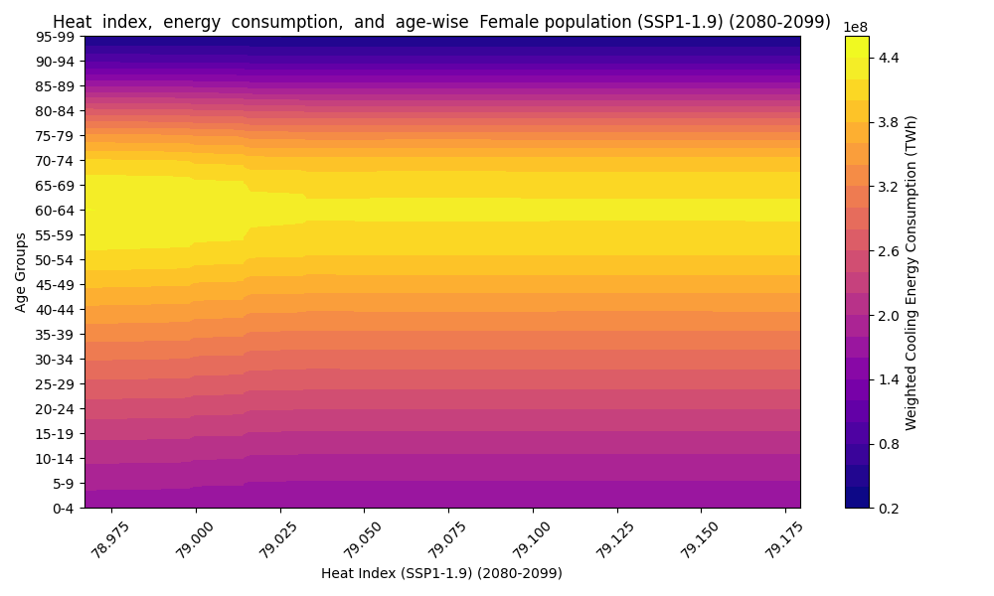
Figure 6: Females, SSP1-1.9 (2080–2099).
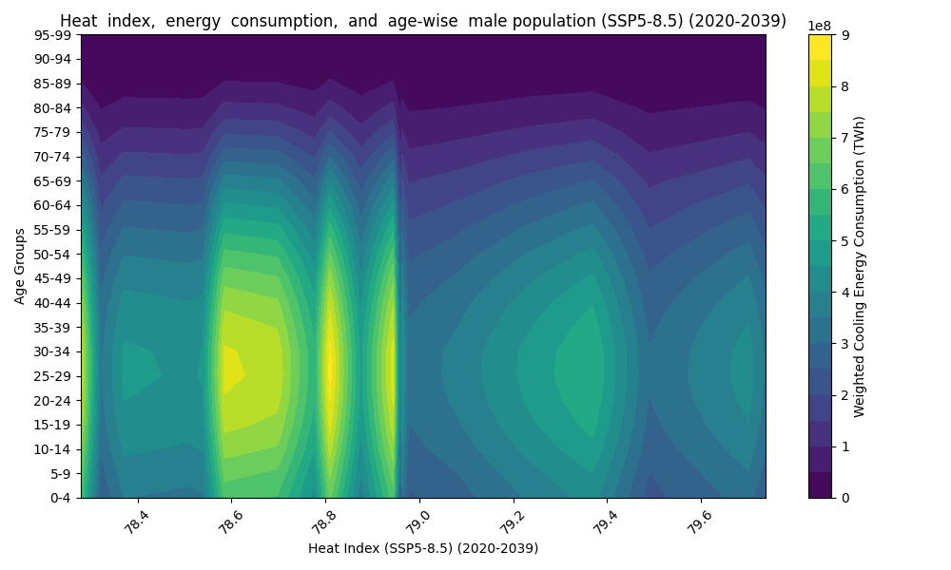
Figure 7: Males, SSP5-8.5 (2020–2039)
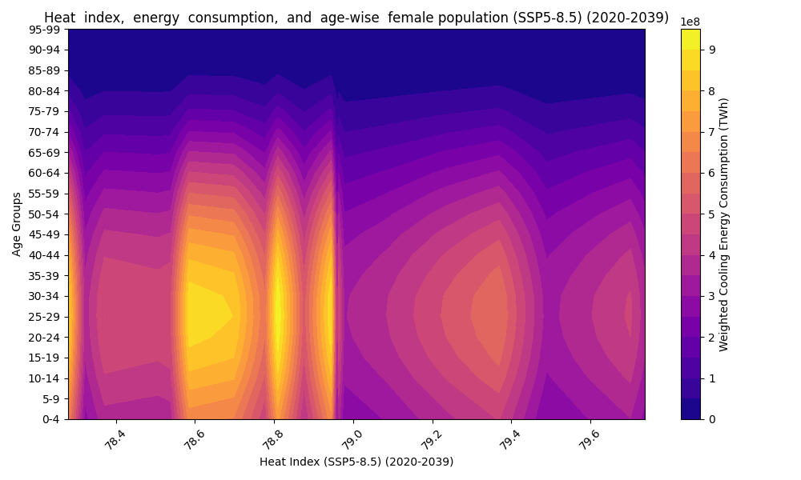
Figure 8: Females, SSP5-8.5 (2020–2039)
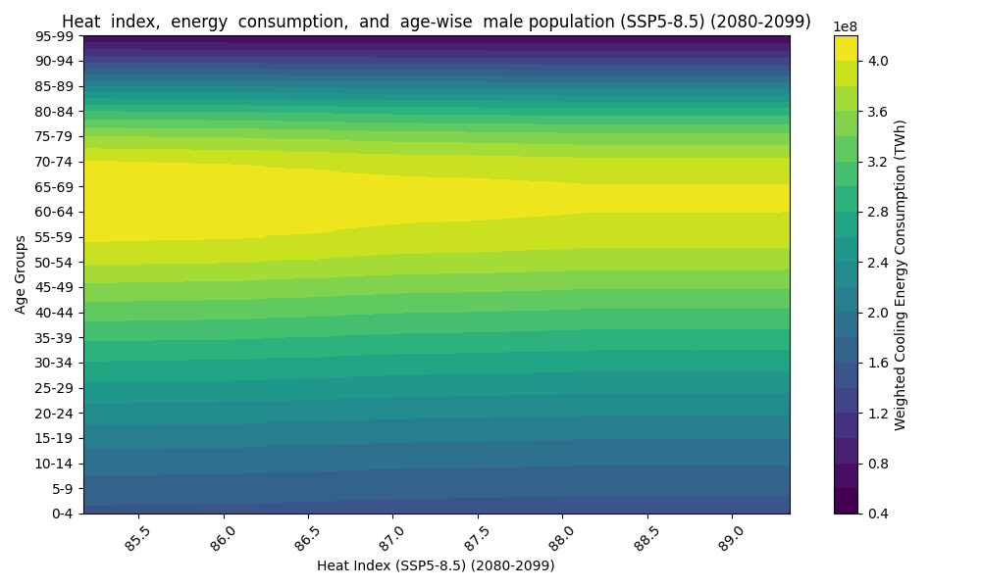
Figure 9: Males, SSP5-8.5 (2080–2099)
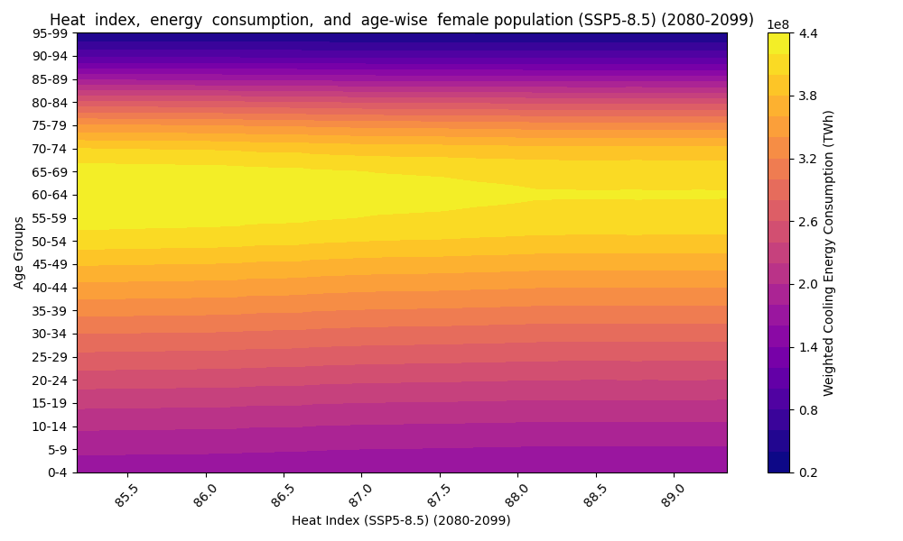
Figure 10: Females, SSP5-8.5 (2080–2099)
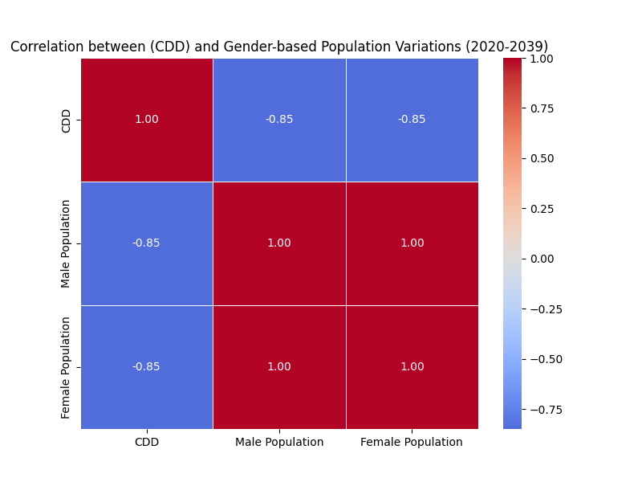
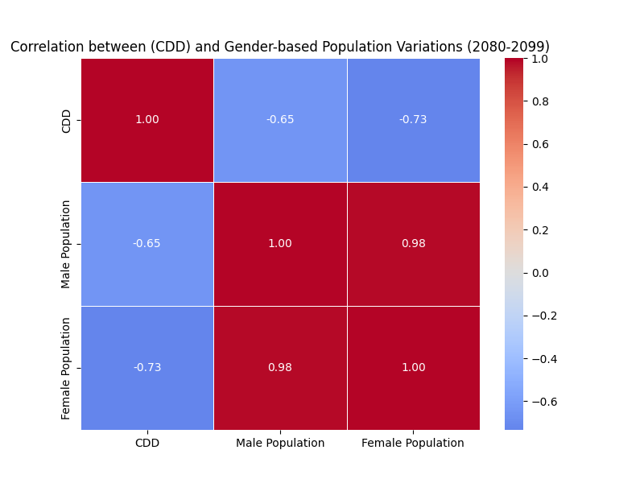
Figure 11: SSP1-1.9 (2020–2039)

Figure 12: SSP1-1.9 (2080–2099)
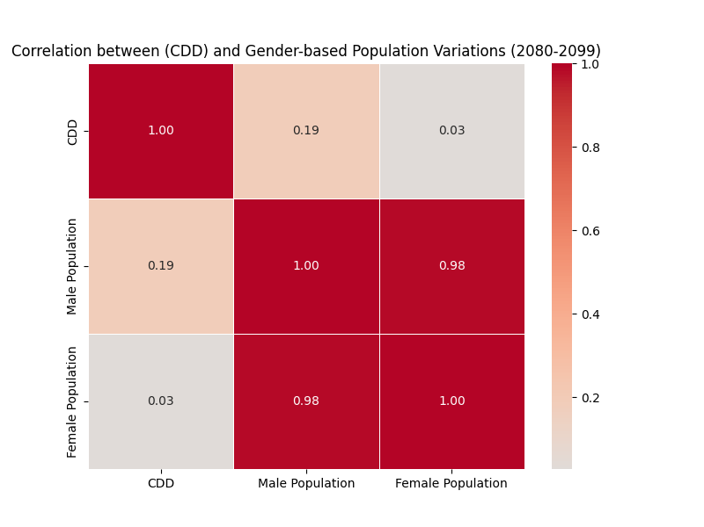
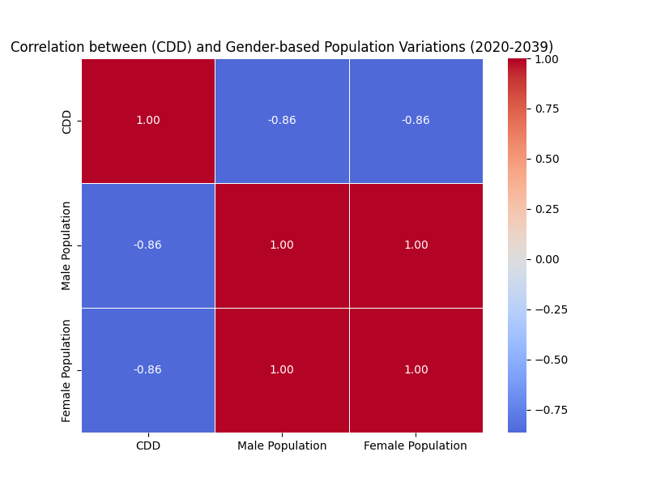Figure 13: SSP5-8.5 (2020–2039)

Figure 14: SSP5-8.5 (2080–2099)

References
[1] Debnath, R., Bardhan, R., & Bell, M. L. (2023). Lethal heatwaves are challenging India’s sustainable development. PLOS Climate, 2(4), e0000156. https://doi.org/10.1371/journal.pclm.0000156
[2] Bureau of Energy Efficiency. BEE Final Report. Bureau of Energy Efficiency, Ministry of Power, Government of India, n.d.
[3] Riahi, K., van Vuuren, D. P., Kriegler, E., et al. (2017). The Shared Socioeconomic Pathways and their energy, land use, and greenhouse gas emissions implications. Global Environmental Change, 42, 153–168.
[4] Lutz, W., Goujon, A., Samir, K. C., et al. (2019). Demographic scenarios for the SSPs. Nature Climate Change, 9(4), 255–262.
[5] World Bank Climate Change Knowledge Portal, https://climateknowledgeportal.worldbank.org/.
[6] Vasudha Foundation. (2024). India Energy Scenario: For the year 2023-24 | 2nd Edition. Bureau of Energy Efficiency, Ministry of Power, Government of India.
[7] Mastrucci, A., Byers, E., Pachauri, S., & Rao, N. D. (2019). Modeling global residential cooling demand under climate change. Energy and Buildings, 199, 186–203. https://doi.org/10.1016/j.enbuild.2019.06.047
[8] Kovats, R. S., & Hajat, S. (2008). Heat stress and public health: A critical review. Annual Review of Public Health, 29, 41–55. https://doi.org/10.1146/annurev.publhealth.29.020907.090843
[9] Anderson, G. B., Bell, M. L., & Peng, R. D. (2018). Heat-related mortality risk in the United States. Environmental Research Letters, 13(5), 054006.
[10] Sailor, D. J., & Pavlova, A. A. (2003). Air conditioning market saturation and long-term response to climate change. Energy, 28(9), 941–951.
[11] Rothfusz, L. P. (1990). The heat index equation. National Weather Service Technical Report.
[12] Isaac, M., & van Vuuren, D. P. (2009). Modeling global residential sector energy demand for heating and air conditioning. Energy Policy, 37(2), 507–521.
[13] Jones, R. N., Patwardhan, A., Cohen, S. J., et al. (2014). Foundations for decision making under climate change. Climate Change, 2(1), 45–62.
[14] Davis, L. W., & Gertler, P. J. (2015). Contribution of air conditioning adoption to future energy use under global warming. Proceedings of the National Academy of Sciences, 112(19), 5962–5967.
[15] Perkins-Kirkpatrick, S. E., & Gibson, P. B. (2017). Changes in regional heatwave characteristics as a function of increasing global temperature. Scientific Reports, 7(1), 12256.
[16] Auffhammer, M., & Mansur, E. T. (2014). Measuring climatic impacts on energy expenditures: A review of the empirical literature. Energy Economics, 46, 522–530.
[17] Gagnon, D., & Kenny, G. P. (2012). Sex differences in thermoregulatory responses during heat stress. European Journal of Applied Physiology, 112(9), 3325–3334.
[18] Samir, K. C., & Lutz, W. (2017). The human core of the shared socioeconomic pathways: Population scenarios by age, sex, and level of education for all countries to 2100. Global Environmental Change, 42, 181–192.
[19] Adger, W. N., et al. (2014). Human security. In Climate Change 2014: Impacts, Adaptation, and Vulnerability. Cambridge University Press.
[20] Watts, N., et al. (2018). The Lancet Countdown on health and climate change: From 25 years of inaction to a global transformation for public health. The Lancet, 391(10120), 581–630.
[21] Lundgren, K., Kuklane, K., Gao, C., & Holmer, I. (2013). Gender differences in thermoregulation and heat stress. Journal of Thermal Biology, 38(5), 221–229.
[22] Biardeau, L. T., Davis, L. W., Gertler, P., & Wolfram, C. (2020). Heat exposure and global air conditioning. Nature Sustainability, 3(1), 25–28.
[23] Ebi, K. L., et al. (2021). Hot weather and heat extremes: Health risks. The Lancet, 398(10301), 698–708.
[24] IEA (2021). The Future of Cooling in India. International Energy Agency. https://www.iea.org/reports/the-future-of-cooling-in-india.

Supplementary Figures 1-52
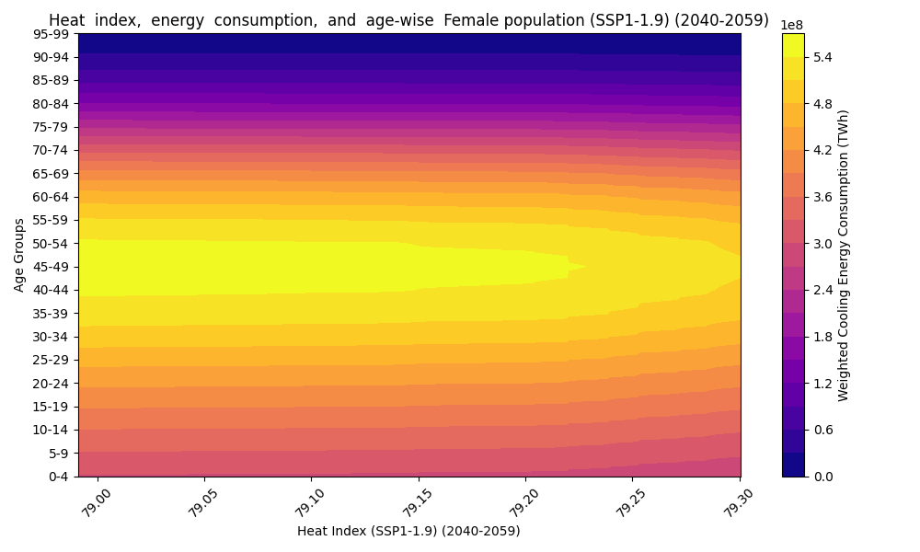
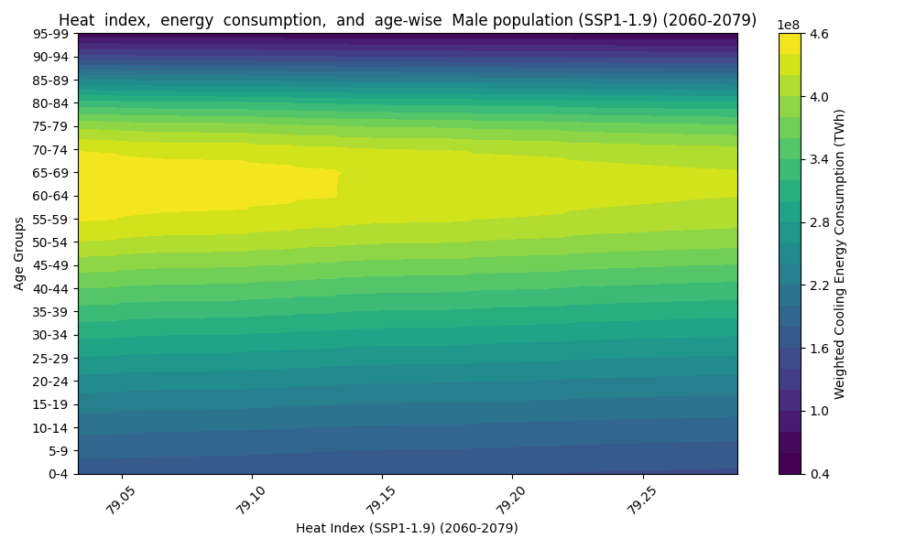
Figure 1: Females, SSP1-1.9 (2040–2059)

Figure 2: Males, SSP1-1.9 (2040–2059)
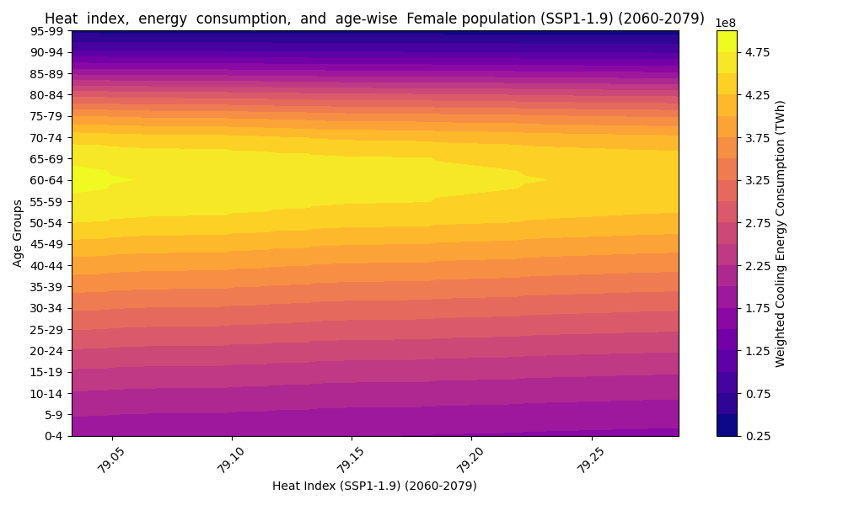
Figure 3: Females, SSP1-1.9 (2060–2079)

Figure 4: Males, SSP1-1.9 (2060–2079)
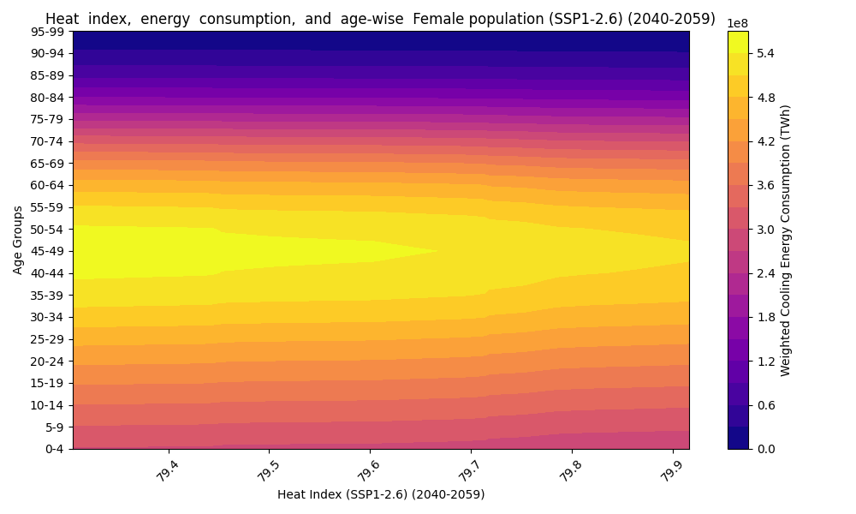
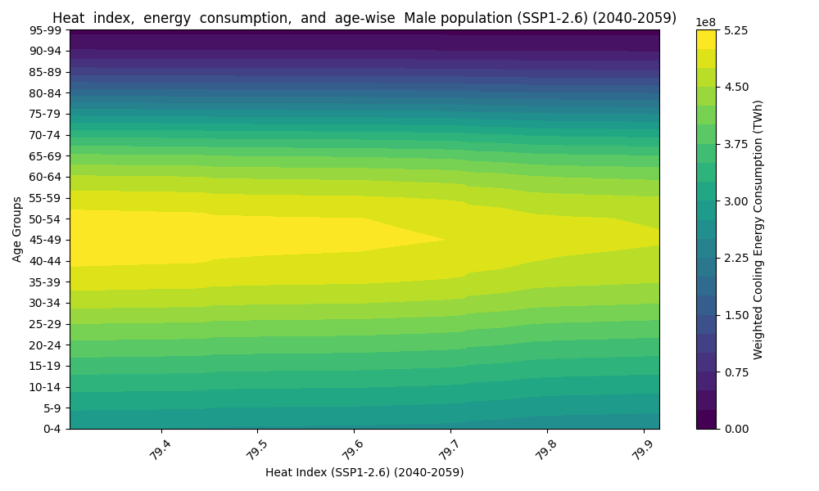
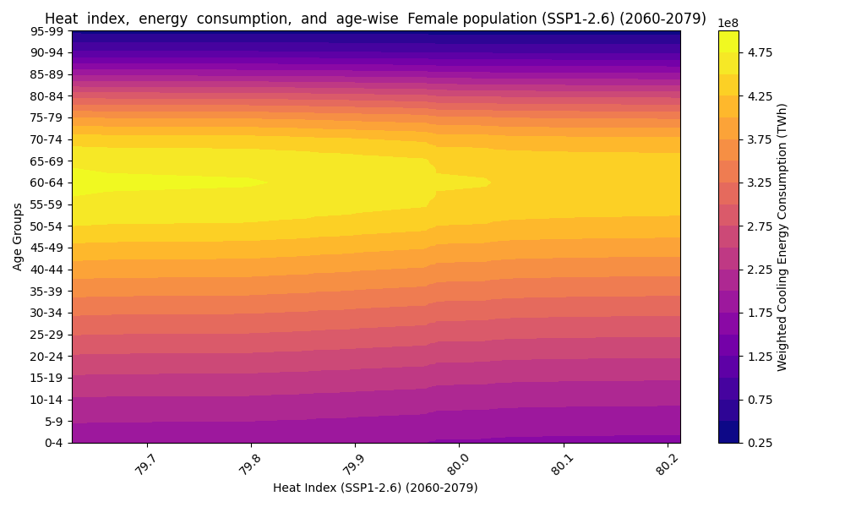
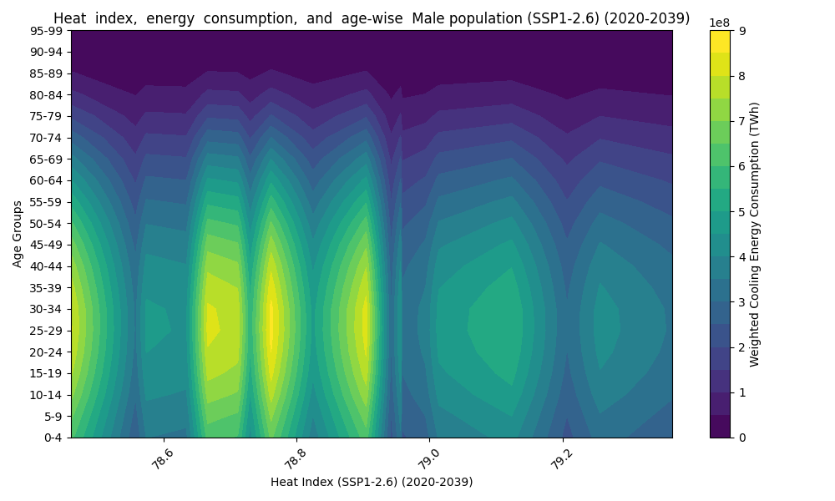
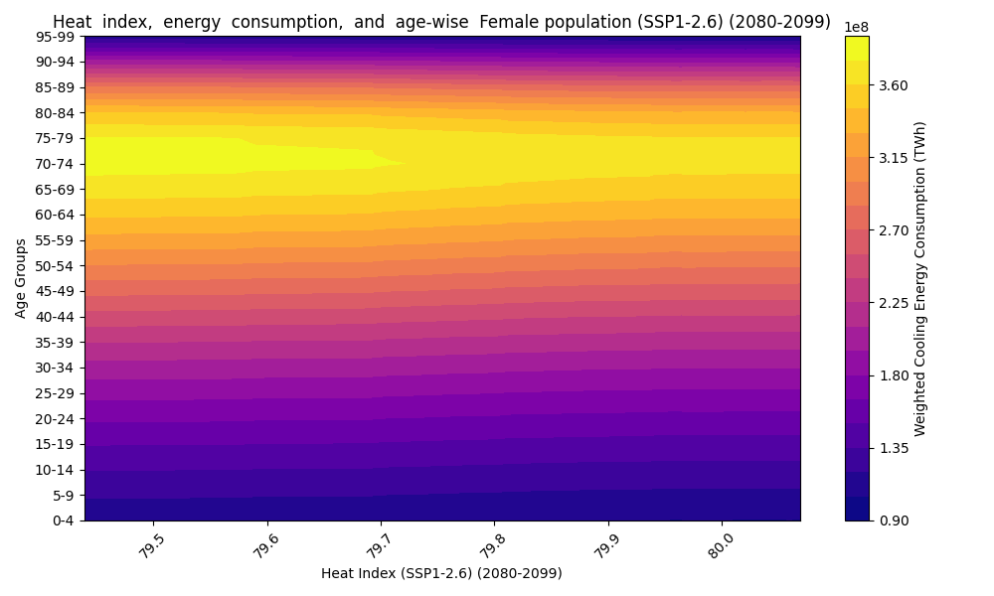
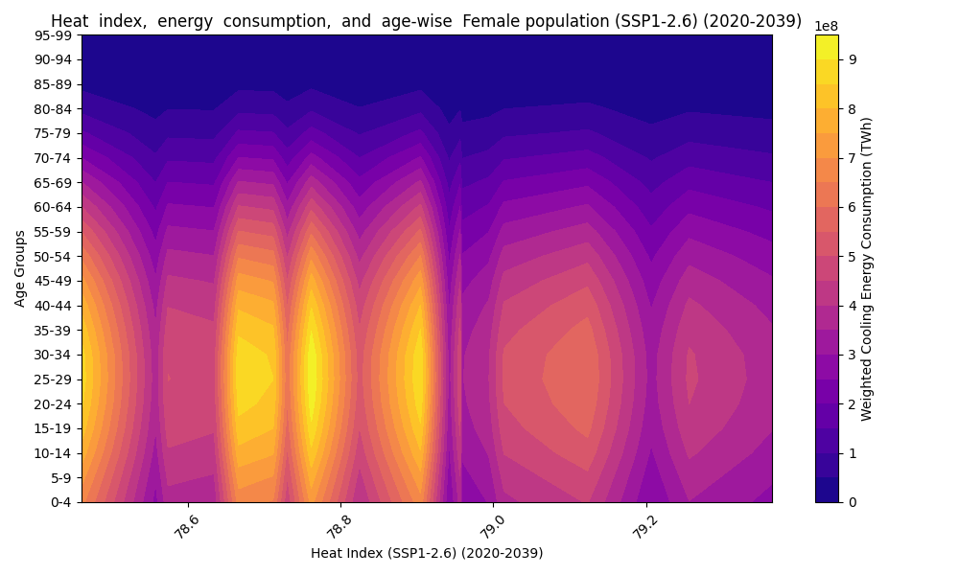
Figure 5: Females, SSP1-2.6 (2020–2039)

Figure 6: Males, SSP1-2.6 (2020–2039)
Figure 7: Females, SSP1-2.6 (2040–2059)
Figure 8: Males, SSP1-2.6 (2040–2059)
Figure 9: Females, SSP1-2.6 (2060–2079)
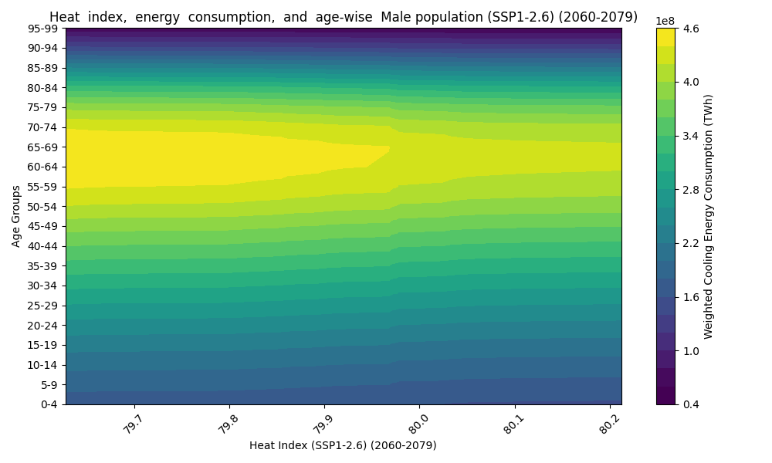
Figure 10: Males, SSP1-2.6 (2060–2079)
Figure 11: Females, SSP1-2.6 (2080–2099)
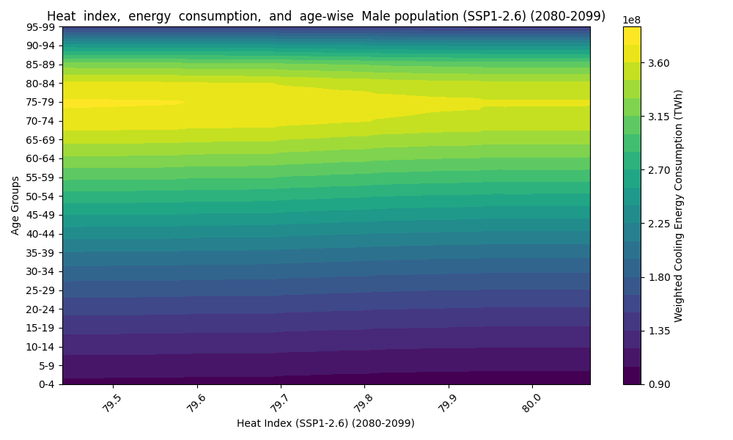
Figure 12: Males, SSP1-2.6 (2080–2099)
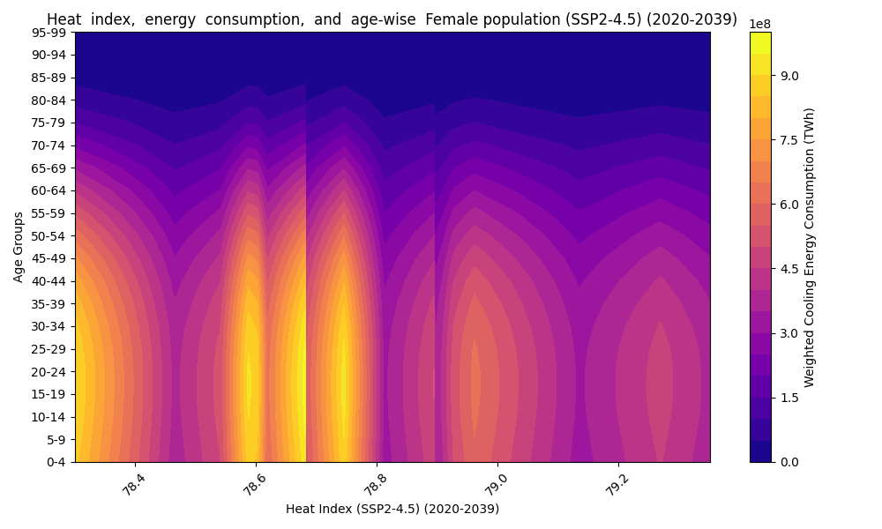
Figure 13: Females, SSP2-4.5 (2020–2039)
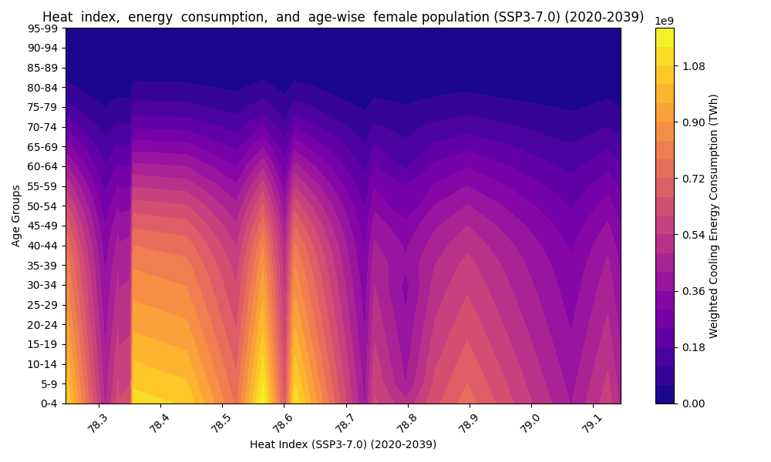
Figure 14: Males, SSP2-4.5 (2020–2039)
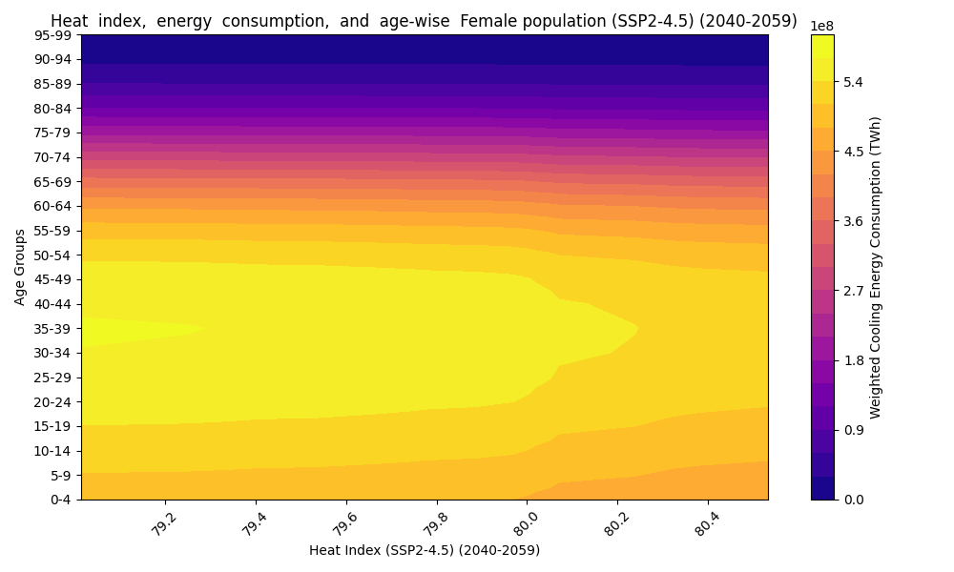
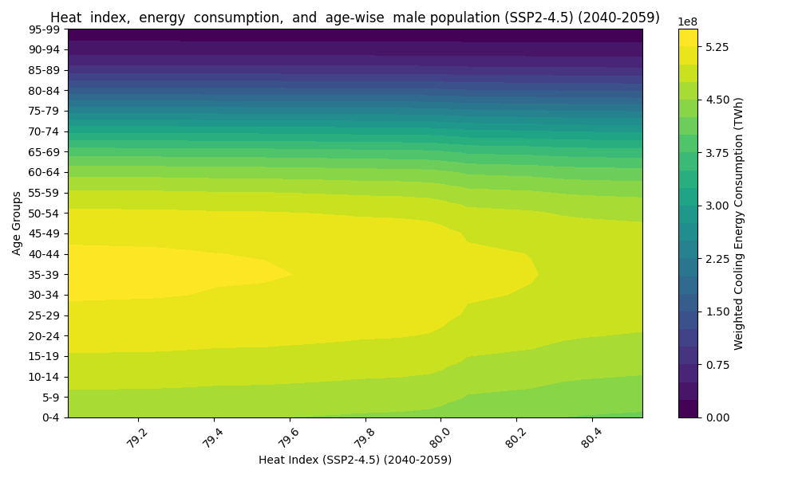
Figure 15: Females, SSP2-4.5 (2040–2059)

Figure 16: Males, SSP2-4.5 (2040–2059)

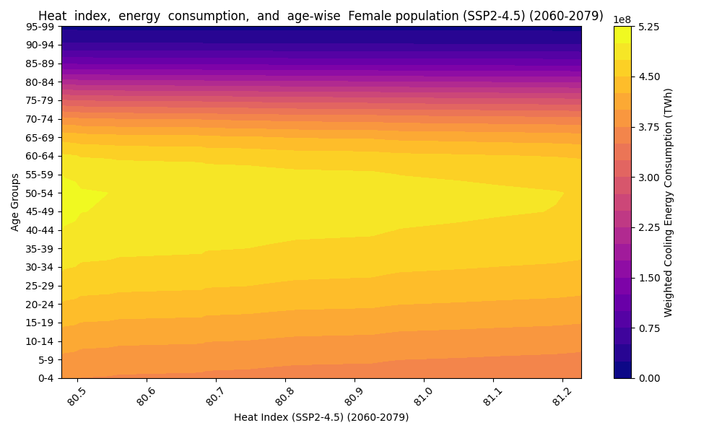
Figure 17: Females, SSP2-4.5 (2060–2079)
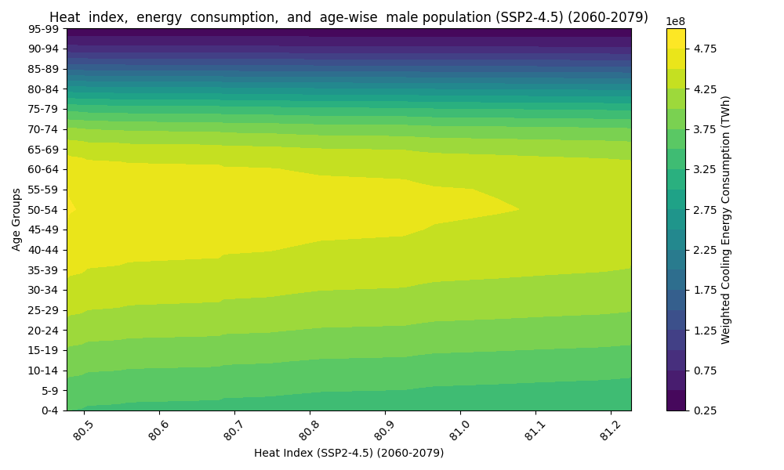
Figure 18: Males, SSP2-4.5 (2060–2079)
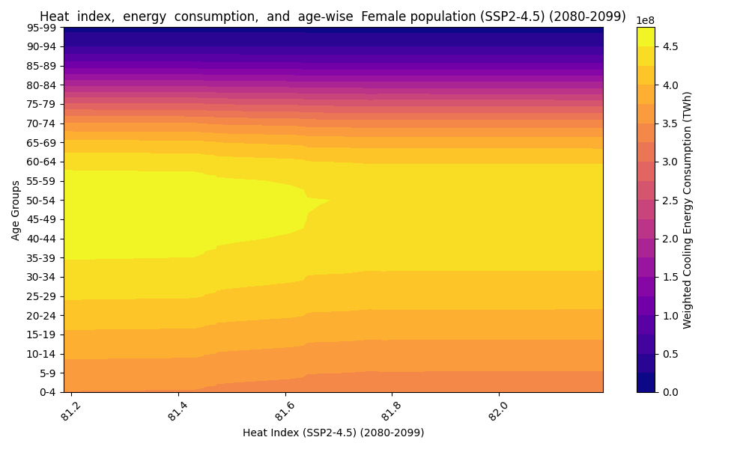
Figure 19: Females, SSP2-4.5 (2080–2099)
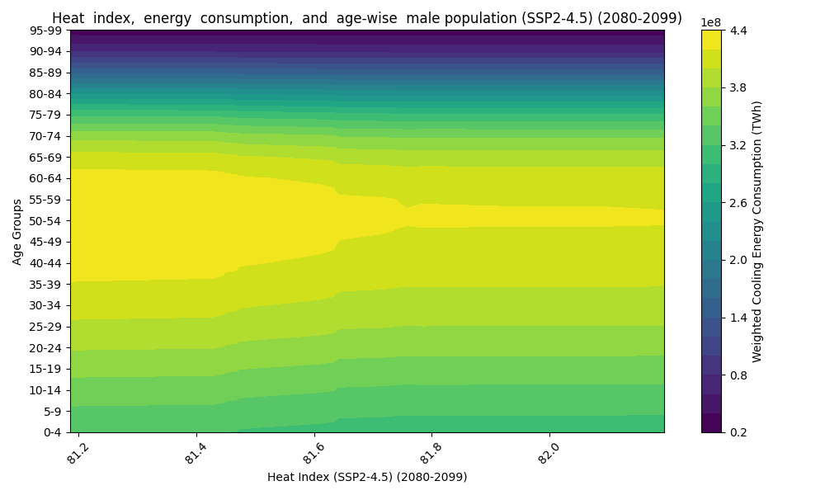
Figure 20: Males, SSP2-4.5 (2080–2099)
Figure 21: Females, SSP3-7.0 (2020–2039)
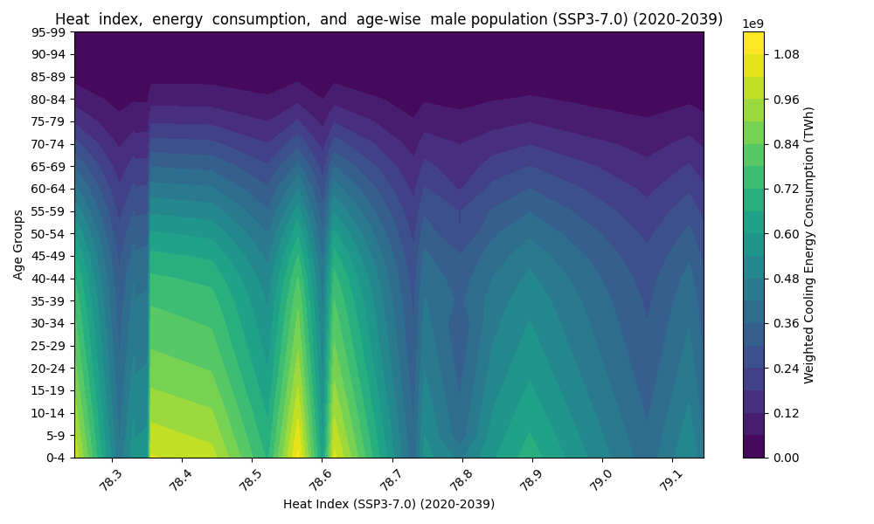
Figure 22: Males, SSP3-7.0 (2020–2039)
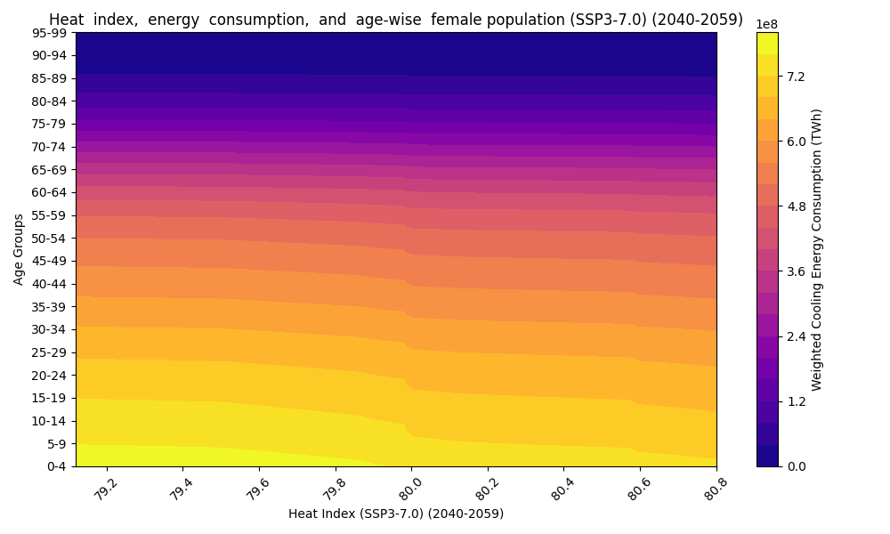
Figure 23: Females, SSP3-7.0 (2040–2059)
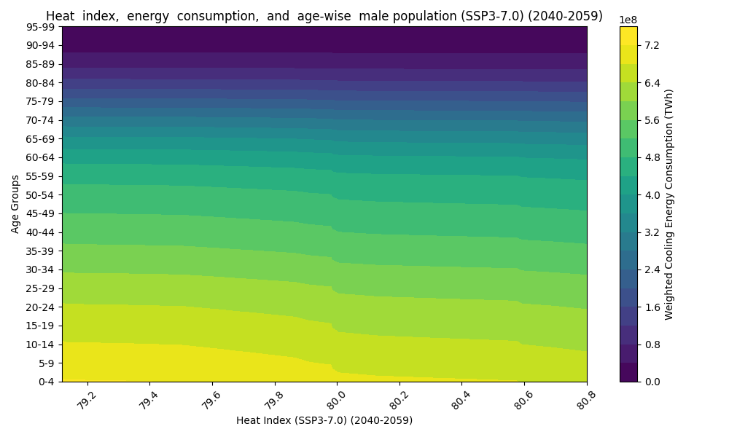
Figure 24: Males, SSP3-7.0 (2040–2059)
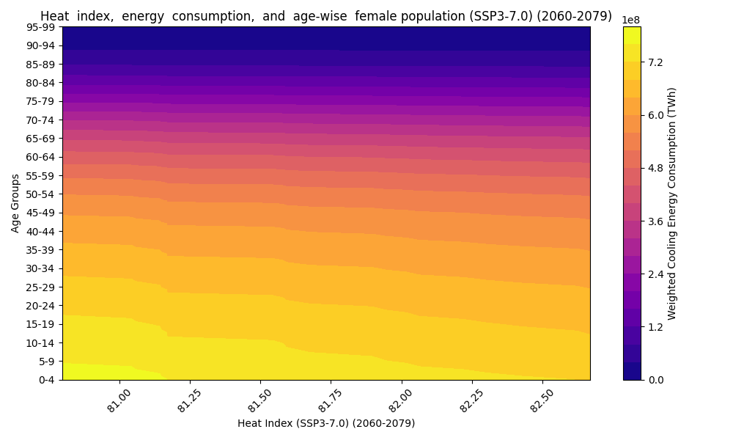
Figure 25: Females, SSP3-7.0 (2060–2079)
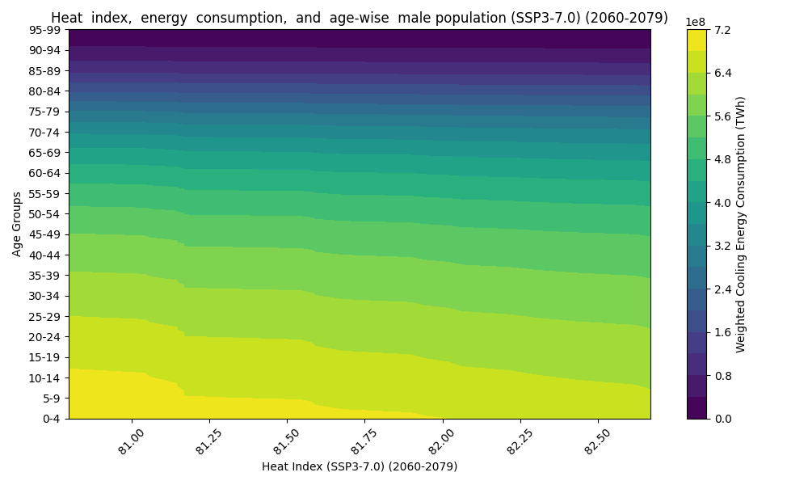
Figure 26: Males, SSP3-7.0 (2060–2079)
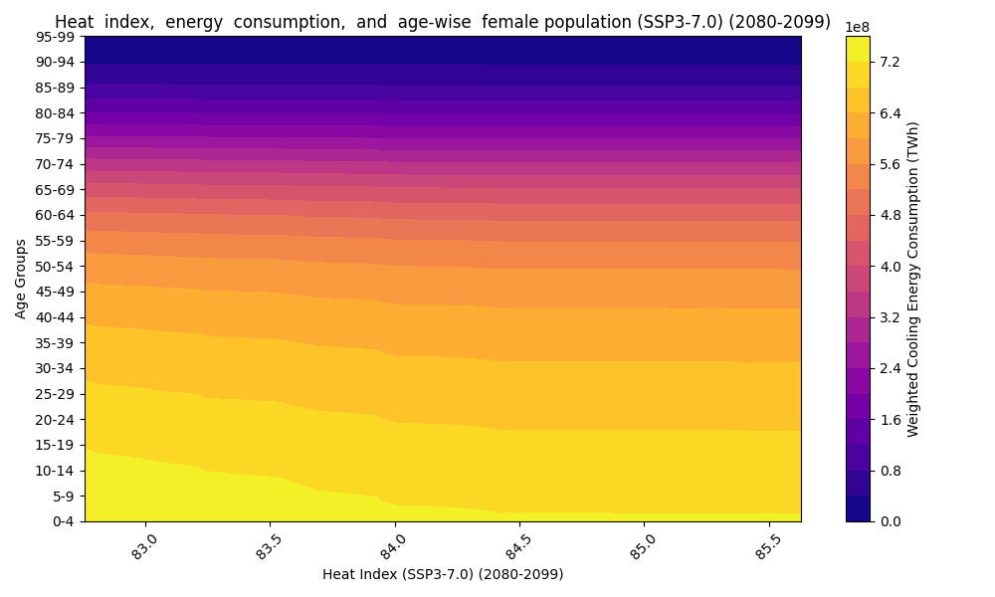
Figure 27: Females, SSP3-7.0 (2080–2099)
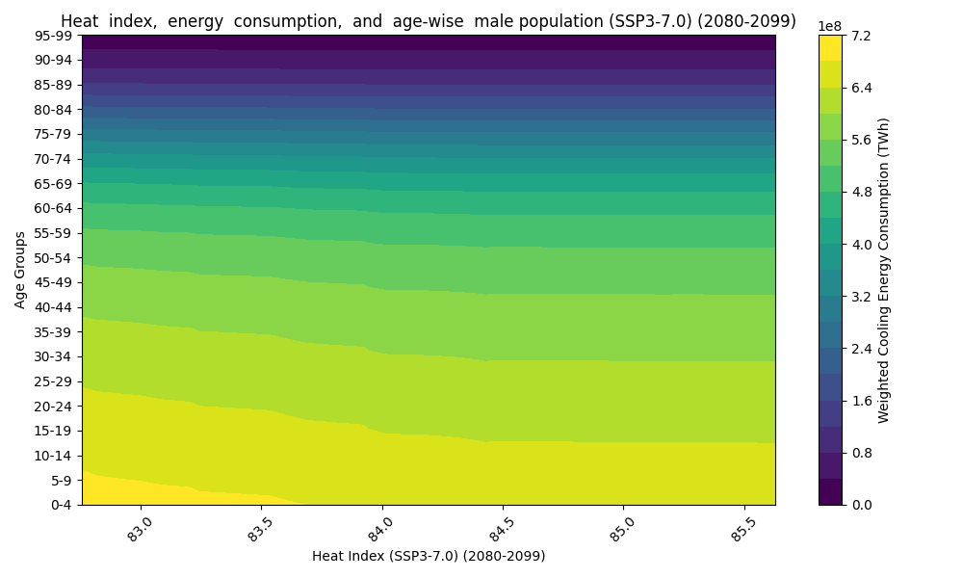
Figure 28: Females, SSP3-7.0 (2080–2099)
Figure 29: Females, SSP5-8.5 (2020–2039)
Figure 30: Males, SSP5-8.5 (2020–2039)
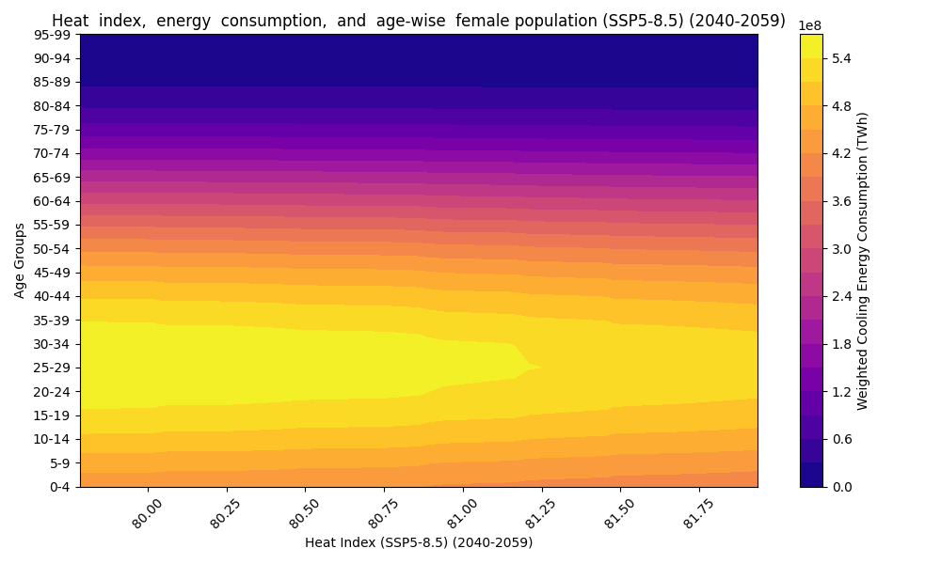
Figure 31: Females, SSP5-8.5 (2040–2059)
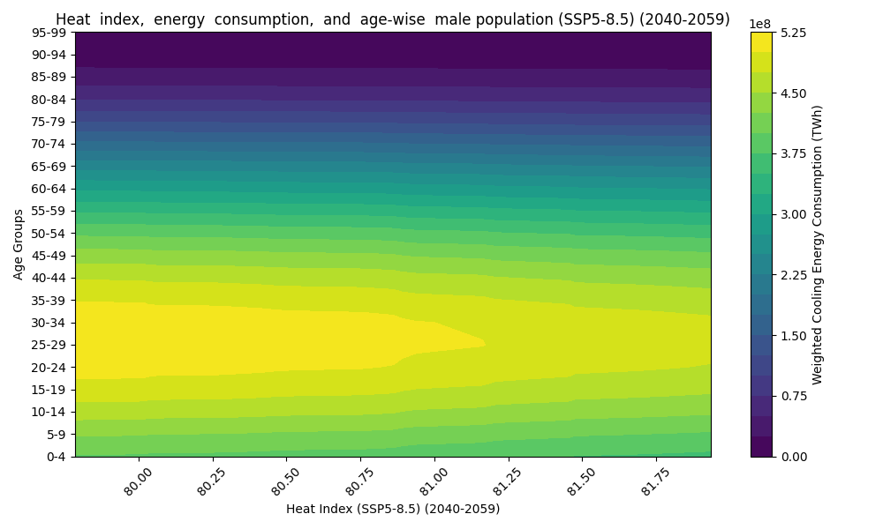
Figure 32: Males, SSP5-8.5 (2040–2059)
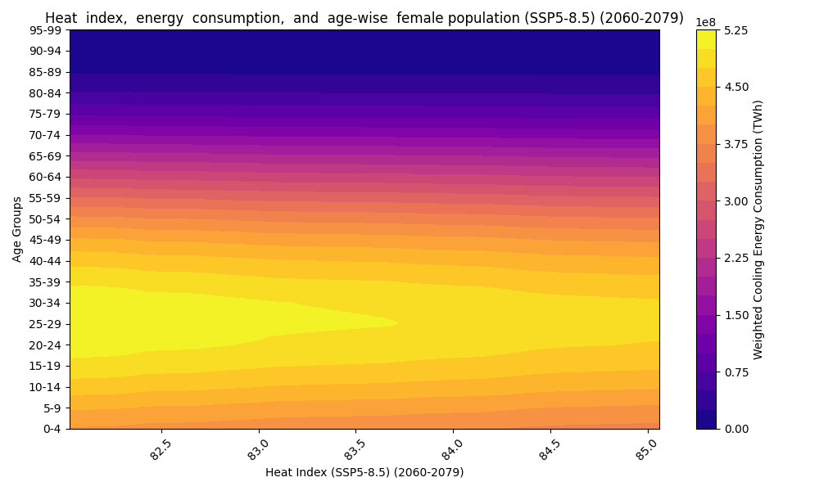
Figure 33: Females, SSP5-8.5 (2060–2079)
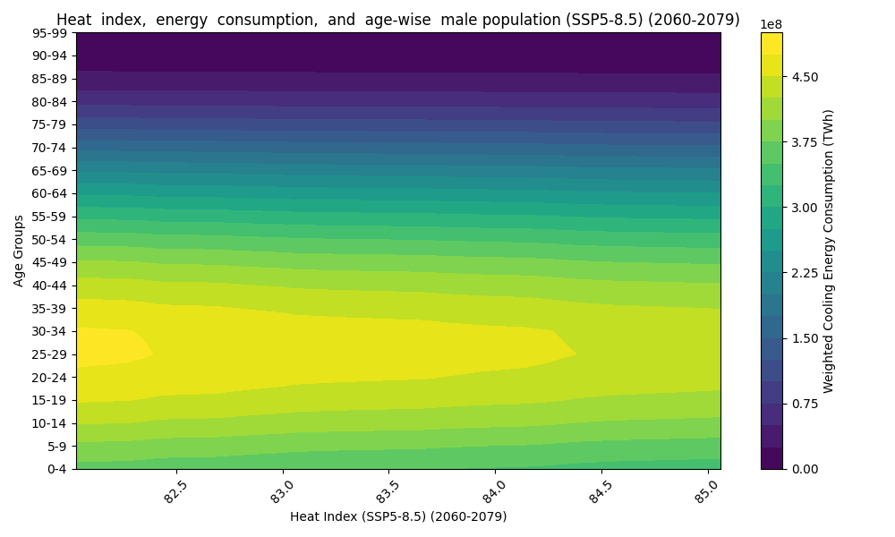
Figure 34: Males, SSP5-8.5 (2060–2079)
Figure 35: Females, SSP5-8.5 (2080–2099)
Figure 36: Males, SSP5-8.5 (2080–2099)
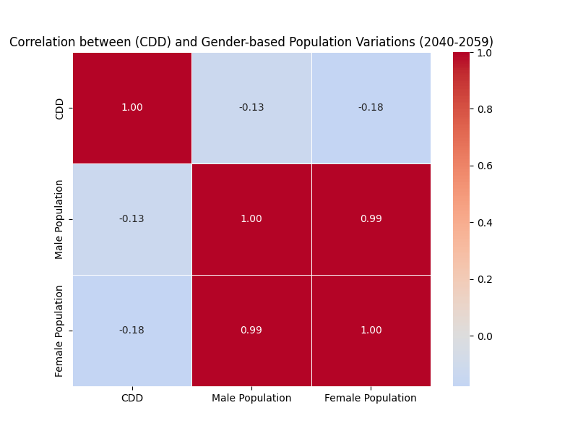

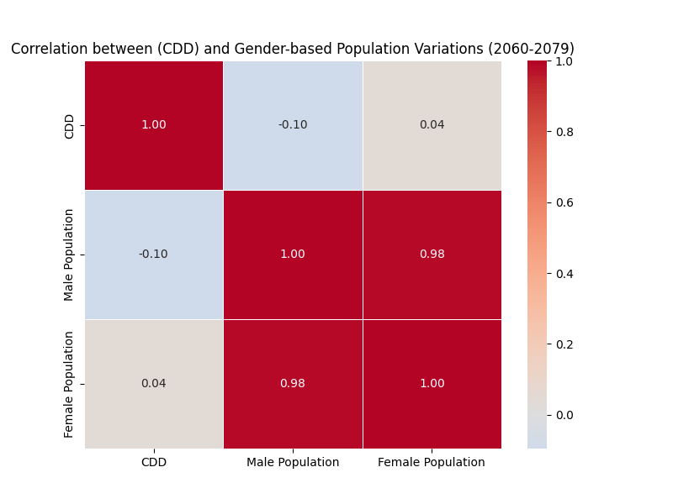
Figure 37: SSP1-1.9 (2040–2059)

Figure 38: SSP1-1.9 (2060–2079)
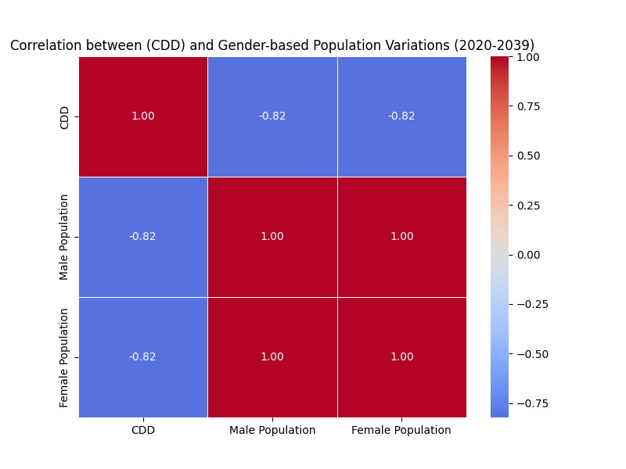

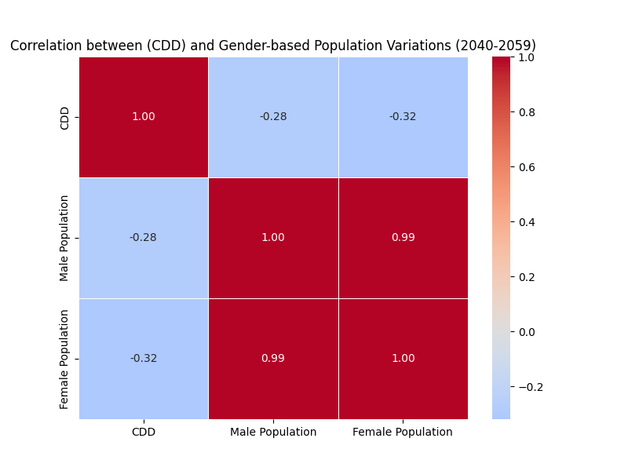
Figure 39: SSP1-2.6 (2020–2039)

Figure 40: SSP1-2.6 (2040–2059)
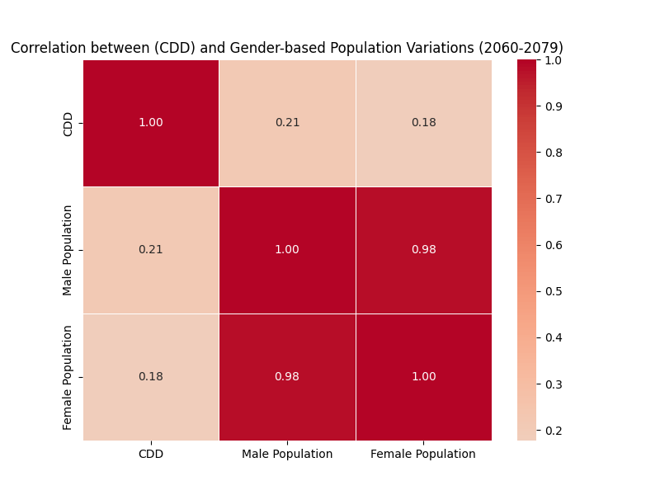

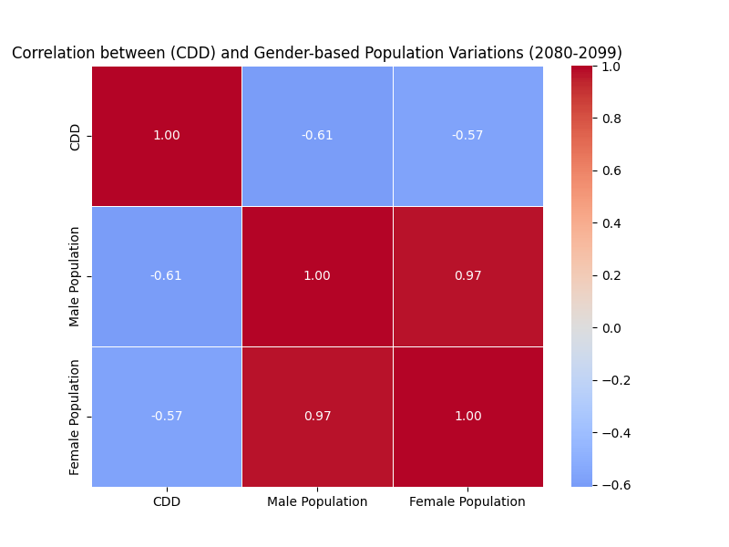
Figure 41: SSP1-2.6 (2060–2079)

Figure 42: SSP1-2.6 (2060–2079)
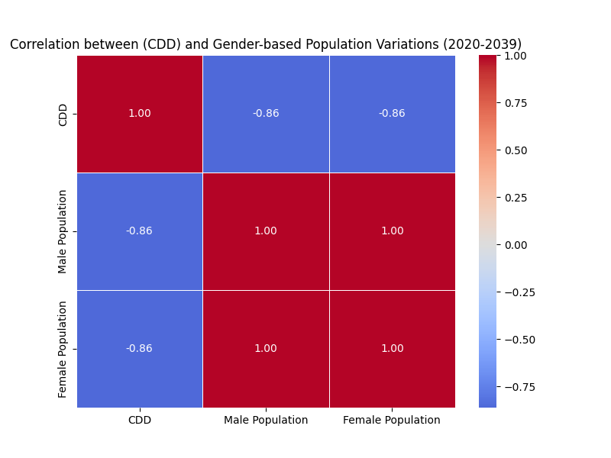

Figure 43: SSP2-4.5 (2020–2039)
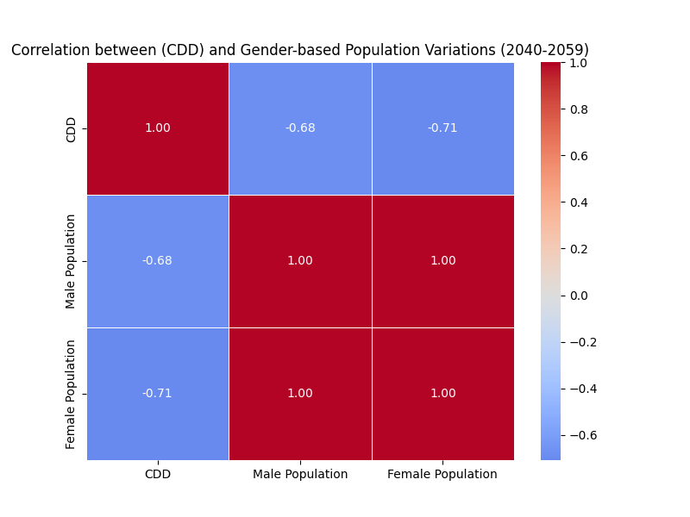

Figure 44: SSP2-4.5 (2040–2059)
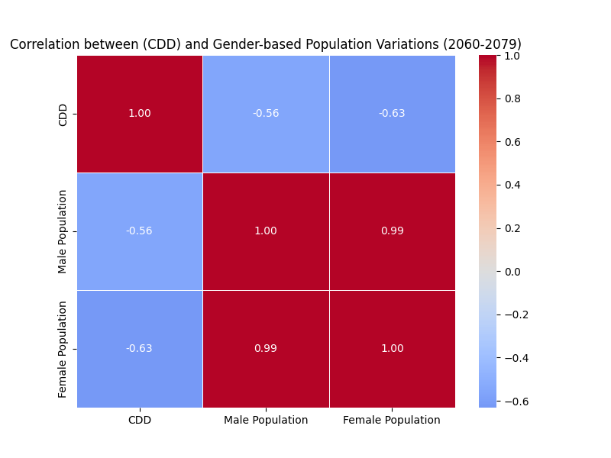

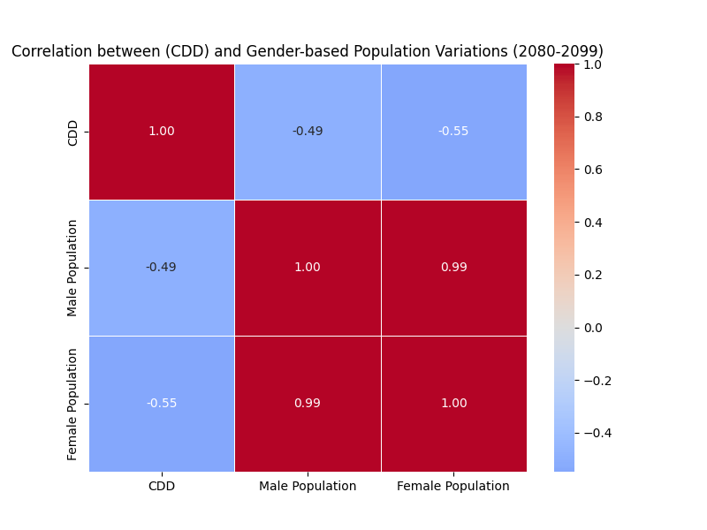
Figure 45: SSP2-4.5 (2060–2079)

Figure 46: SSP2-4.5 (2080–2099)
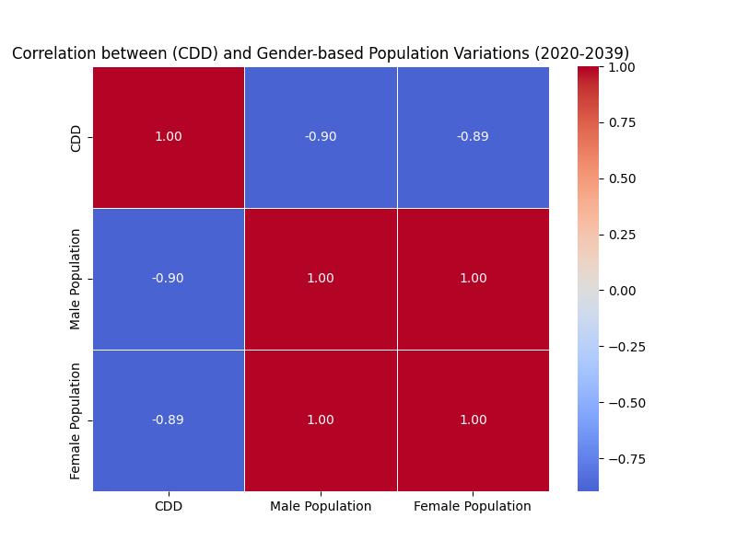

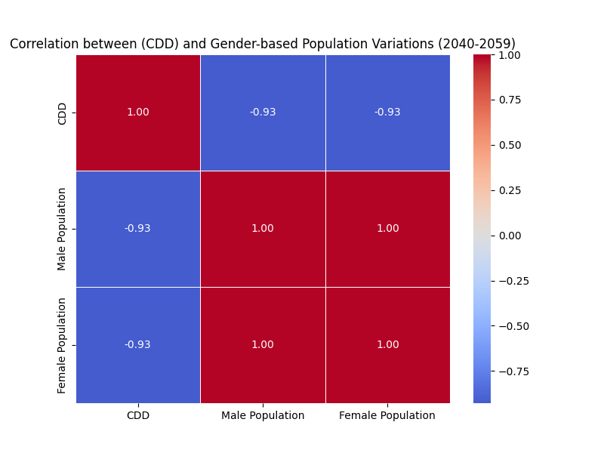
Figure 47: SSP3-7.0 (2020–2039)

Figure 48: SSP3-7.0 (2040–2059)
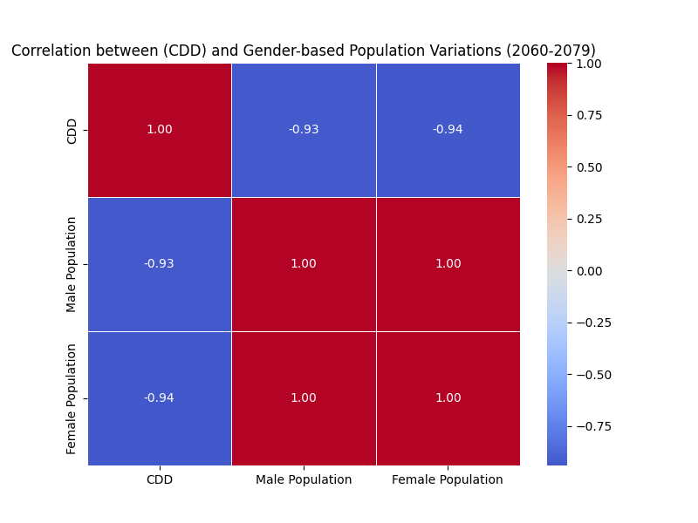

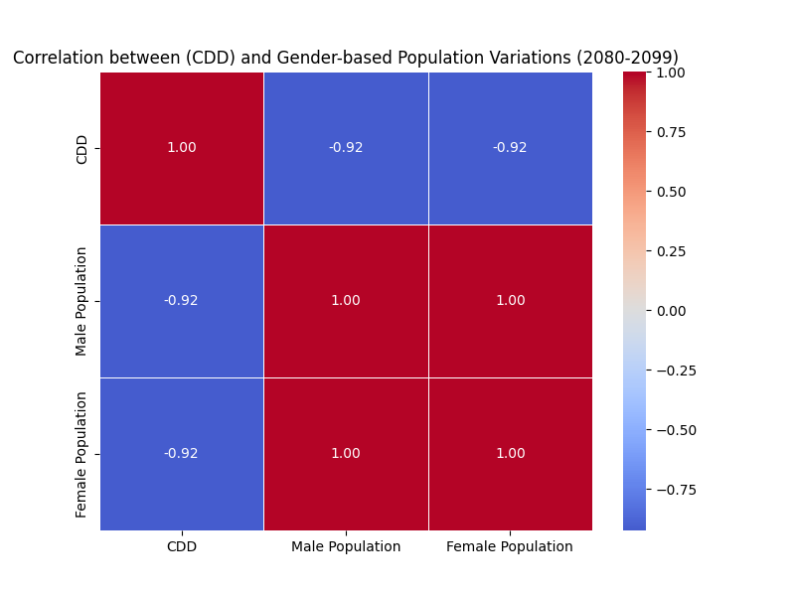
Figure 49: SSP3-7.0 (2060–2079)

Figure 50: SSP3-7.0 (2080–2099)

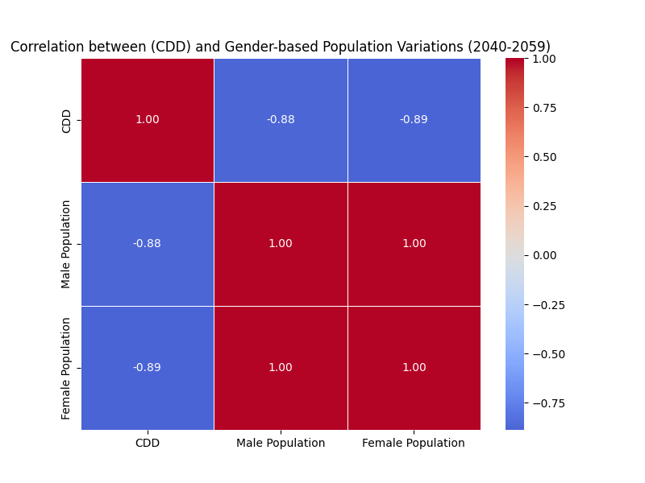

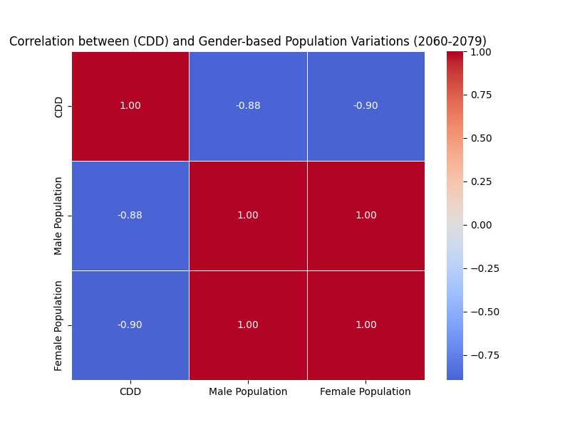
Figure 51: SSP5-8.5 (2040–2059)

Figure 52: SSP5-8.5 (2060–2079)

